Terminal Report of the NJB Sponsored Project

Manufacture of Different Jute and Jute Blended Yarns/ Fabrics (Furnishings & Upholstery) for Home Textiles/Secondary Apparels and Other Jute Diversified Products

Project Serial No.3/Scheme 7.1 of Mini Mission IV under
Jute Technology Mission

THE SOUTH INDIA TEXTILE RESEARCH ASSOCIATION
COIMBATORE - 641 014
July 2011

Introduction
Traditionally Jute was used in the packaging sector for bulk packaging of various commodities. The advent of synthetics has greatly undermined the preeminence of Jute as a premier, flexible packaging material. Abundant availability of plastic materials as well as modern handling, transporting and storing methods led to the replacement of Jute bags. Even in a developing country like India, where large quantity of Jute is produced, the plastic bags are used more and more in packing of fertilizers and chemicals. Over the last four decades these traditional outlets have been under severe pressure from commodity (Synthetic packaging material (Plastic, Polypropylene)) on cost economic ground. The global demands for this product as a packaging material has not only changed very fast but also eroded the traditional market severely. To save the industry on one side and to protect the cultivators on the other, our urgent need for the development of value added diversified Jute products is being felt by the industry as well as by Government of India.

As a consequence, the very survival of this virtual industry has become question mark, demanding urgent measures for the development of appropriate technology/methodology to help to produce non-traditional value added diversified products from Jute. Hence, Government of India jointly with United Nations Development Programme (UNDP) has initiated a number of projects in the area of Jute diversification during 90^{s}. These projects carried out in laboratories and institutes in India in Research and Development of Jute and other textile fabrics have identified the vast potentiality for the development of a wide spectrum of Jute diversified products by blending Jute with fibres like Viscose, Polyester, Acrylic, Cotton and Polypropylene etc.

Table cloth, Cushions covers, bed covers, sofa covers, curtain cloth, table mats, prayer mats, napkins, aprons, blankets etc. are made of Cotton and Cotton in combination with other textile fibres. Jute blended fabrics can replace the Cotton and its blended fabrics for Home textiles applications. However, the technology options identified were mostly on the lab – scale and efforts are yet to be taken on commercialization of appropriate technologies for the manufacture of Jute diversified products.
Sequel to this revelation National Jute Board awarded a project to SITRA in the name “Manufacture of Different Jute and Jute blended yarns / fabrics (Furnishings & Upholstery) for Home textiles / Secondary apparels and other Jute diversified products with project serial No.3 / Scheme 7.1 of mini mission IV under Jute technology Mission.
The project aims to spin Jute blended yarns in Jute spinning system and to manufacture different Jute diversified products.
Diversification of Jute products for textile use requires spinning of lighter yarns.
To spin lighter yarns, Jute has to be blended with other
Man-made fibres like Viscose, Polyester, and Acrylic etc. This study is an attempt in this direction.

1 Objectives of the Project

- Standardization of process techniques to spin Jute blended yarns (Jute blended with viscose, polyester and acrylic) in Jute spinning system.
- Standardization of process technique in weaving and knitting to manufacture the different JDPs.
- Manufacture of furnishings, upholstery, shawls, niwars, curtain fabrics and secondary apparels in handlooms and powerlooms using the Jute blended yarns manufactured in bulk quantities.
- To work out the techno-economics of manufacturing the identified JDPs.
and
- To conduct dissemination seminars/workshops towards market promotion

2 Summary Report on Literature Survey
The research team of officers have received the available literature at SITRA library/Net other places regarding manufacture of Jute blended yarns and products. To begin with efforts were made to collect and compile all the published information relating to the prescribed objective of the proposed study.
The findings are as follows,
- Producing Jute blended yarns is to set products of desirable range of properties to suit different end – use.
- To overcome short supply of natural fibres.
- Jute fibre is mainly used for manufacturing packaging fabrics only.
- Jute fibre as singly cannot be suitable for producing the diversified Jute products.
- Efforts have to be made to blend Jute fibres with other fibres to overcome the deficiencies of Jute fibre.
- To provide cheaper blended substitute products from Jute and Other fibres
- Few R & D efforts on J/V blended trails and research reports were dealt about the blending of Jute / Viscose and Yarn quality attributes.
- To our knowledge, there is no published research study on blending of Jute/Polyester and Jute/Acrylic.
- No available information on quality attributes of Jute/Polyester blended yarns and Jute/Acrylic blended yarns.
- Jute strands with Viscose fibre in the form of cut staple were processed in the breaker card tried.
- Jute slivers were mixed with Viscose rayon slivers at the first Jute drawing frame.
- Core – spun blends trails in the flyer frame was also studied.
- Jute/Cotton blended yarns in short staple spinning system has been developed with appropriate technology.
- Trails on Jute/Cotton blends in rotor spinning system was reported
- Friction spinning technology could be used for manufacturing core yarns with Jute yarns as core and Polypropylene fibres as sheath.
  - Adequate reports are not available on Jute/Polyester blends and Jute/Acrylic blends.
  - Lab trails results are available only on Jute / Viscose blends.
  - Bulk trails on Jute blended yarns sofar was not taken in Jute Spinning System.
3 Survey of Literature / Journals / Publications / Directory / Books

- Cumming I G and Atpinson RR, “The blending of Jute with man – made fibres”, J. Textile Institute, Annual conference paper proceedings 54 (July 1963).
- Debnath C R, “Some optimum conditions for blending of Jute and Viscose Rayon”, J. Textile Institute, 65(1974)
- Debnath C R and Bandyopadhyay S B, “Jute – Viscose Blending: Some optimum conditions”, Textile Research Journal (May 1974)
- Stout H P, “Fibre and yarn quality in Jute spinning”, A Monograph published by The Textile Institute, 1988
- Palit S, Aditya R N, Banerjee D, Chakraborty T N and Chatterjee G, “Ring spinning – A new approach in producing textile grade yarns from Jute and its blends”, Proceedings of the 17th Annual Technological Conference on Role of Jute in Conventional & Diversified Areas, held at IJIRA during 20th and 21st January 1994.
- Chakaraborthy T N et al, “Identification of Suitable Jute Variety for Diversified End Uses”, Proceeding of 17th Technical Conference held at IJIRA, Kolkata, January 1994.
- Indra Doraiswamy and Chellamani K P, “Processability of Jute Blends in Short Staple Ring Spinning System”, Proceedings, ATC 95, 3rd Asian Textile Conference held at Hongkong Polytechnic University during September 1995, P. 515 – 519.
- Plawat V, “Development in Spinning of Jute Blended Yarns”, paper presented at the JUTECONFO ’96 held at PSG College of Technology, Coimbatore during May 1996.
- Indra Doraiswamy and Chellamani K P, “Development of Fine Quality Jute Fibre – Need of the Hour, Express Textiles – 1st Anniversary Issue, April 1997, P. 33 and 34.
- Techno-economic Feasibility Studies for Producing Jute/Jute Blended Yarns, Report prepared by ATIRA, Ahmedabad, October 1997.
- “Importance of Fine Jute Fibre in Manufacturing Jute and Jute Blended Yarn on Different Spinning Technologies”, A Study Group Report by IJIRA, SITRA, ATIRA, WRA and Aravind Mills Limited, Proceedings of the 20th Technological Conferences held at IJIRA, Kolkata during April 1998.
- Indra Doraiswamy and Chellamani K P, “Jute and Jute blended Yarn Spinning”, A monograph brought out by SITRA, 2000
- Norms for the Jute Industry – IJIRA 2001
- Sur D, “Quality standards for Jute yarns”, work shop on Development of Jute, IJIRA, Jan 2002
- Indra Doraiswamy and Chellamani K P, “Science and Technology in the Manufacture of Jute Products”, a monograph brought out by SITRA, 2004
- Understanding Jute yarn – De Banjan Survery – Dec 2005
- Need Assessment / Market Survey Report. Specific Information about the Manufacturers Working on the Process / Products.

  - Need assessment
- It has already been described in the previous chapters that the necessity for manufacturing of Jute blended yarns / Fabrics (Jute/Viscose, Jute/Polyester & Jute/Acrylic) in Jute Spinning System and can replace cotton fabrics for home textile applications
- Standardization of process techniques and to work out the
techno – economics of manufacturing the identified JDPS.
- Bulk trails on Jute blended yarns sofar was not taken in Jute Spinning System.

  - Market survey report

- Jute emporium, Kolkata
- Jute shoppe, Kolkata
- Gariahat shopping centre, Kolkata
- Burrabazar whole sale shopping centre, Kolkata
- Hand loom & Handigrafts product sales counter, Kolkata
- Champdany show room, Kolkata
- Erode market, Erode (Tamil Nadu)
- T. Nagar Chennai market, Chennai
- M/s Meenaatshi Enterprises, Komarapalayam
(Tamil Nadu)
- Chen Co-optex, Chennimalai (Tamil Nadu)
- Itchchipatty Weavers Co-operative Society, Chennimalai
(Tamil Nadu)
- The Vijayamangalam Weavers Co-operative Society, Vijayamangalam – 638 056 (Tamil Nadu)
- Bhavani Weavers Co – Operative Society, Bhavani (Tamil Nadu)
- Chinthamani Weavers Co – Operative Society, Bhavani
(Tamil Nadu)
- Moovendar Weavers Co – Operative Society, Bhavani
(Tamil Nadu)
- Aringar Anna Weavers Co – Operative Society, Bhavani
(Tamil Nadu)
- Elongo Weavers Co – Operative Society, Bhavani (Tamil Nadu)
- Ootratchikottai Weavers Co – Operative Society, Bhavani
(Tamil Nadu)
- Annai Sathya Weavers Co – Operative Society, Bhavani
(Tamil Nadu)
- Ashoka Exports, Kolkatta
- Gajalakshimi & Co., Bhavani (Tamil Nadu)
- N. D. M. Textiles, Bhavani (Tamil Nadu)
- M/s Balaji Fabs, Komarapalayam (Tamil Nadu)
- 100% Jute yarn products from coarser counts are available
- Union fabrics from Jute blended with other fibres are available in some places. It has been informed that the non-availability of fine variety Jute products in the market.
- There is scope for fine Jute blended yarn fabrics to replace the products manufactured from other fibres (100% cotton, 100% acrylic and other Man-made fibre blends) particularly for Home textiles.
- There is no commercial products made using Jute / Acrylic and Jute/Polyester blended yarns.
  - Specific information about the manufacturers working on the process / products.

Feedback information from,
- M/s Sri Lakshmi Srinivasa Jute Twine Mills (P) Ltd, Bobbili road, Rajam – 532127 (A.P)
- M/s S. K. S. N Jute Twine Mills (P) Ltd, Rajam –
532 127 (A.P)
- M/s Rajam Poly Packs Limited, Pondru road, Rajam – 532 127 (A.P)
- M/s Saroja Jute Mills (P) Ltd, Vijayanagaram, Bobbili – 535 558 (A.P)
- M/s Sri Venkata Balaji Jute Mills (P) Ltd, Amadalavalasa – 532 185 (A.P)
- M/s Vijayalakshmi Jute Mills, Rajam – 532 127 (A.P)
- M/s Howrah Jute Mills Co. Ltd, Howrah (W.B)
- M/s Ambika Jute Mills, Belur, Howrah (W.B)
- M/s Ganges Jute Mills Co. Ltd, Bansberia, Hooghly (W.B)
- M/s Hestings Jute Mill, Rishra (W.B)
- M/s Cheviot Co. Ltd (W.B)
- M/s Gloster Jute Mills Limited, Howrah (W.B)
- M/s Kamarhatty Co. Ltd (W.B)
- M/s Meenaatshi Enterprises, Komarapalayam (T.N)
- M/s Sree Gajalakhsmi Enterprises, Bhavani (T.N)
- M/s Sudha Jute Industries, Vellandi valasait, Edappadi, Salem (Tamil Nadu)
- M/s Reliance Industries Limited, Mumbai
- M/s Indo Rama Synthetics (India) Limited, Nagpur (Maharashtra)
- M/s Bombay Dyeing & Manufacturing Co., Limited, Panvel (Maharashtra)
- M/s Pasupathy Acrylon, New Delhi
- M/s Grasim Industries Limited, Worli, Mumbai
- M/s Texperts India PVT. LTD., Goregaon (E), Mumbai
- M/s S & D Fabrics, Bhattian, Ludhiana, Punjab
- M/s Futura Polyesters Ltd., Manali, Chennai
- M/s Lenzing Co., Coimbatore (Tamil Nadu)
- M/s Huma Knit Wears, Bhattian bait, Ludhiana, Punjab

- Mills situated in Kolkata & surroundings are interested to go for value added products by using Jute blended yarns particularly Jute / Viscose
- Not interested for further heavy investments on machinery for manufacturing Jute blended yarns / products
- To ensure the availability of raw material (Man-made fibre – Top form)
- Need for technical know – how and process parameters for manufacturing Jute blended yarns
- Information on process feasibility and cost effectiveness
5 Methodology of R & D Part of the Project
The outcome of market survey reports/feedback information from Jute industries, Handloom/Powerloom sectors, Braided and Tape manufacturers to a conclusion that there have been some efforts in the past for development of such Jute diversified products in the laboratory level (Pilot trails).
None of the exercises did not sustain for various reasons. Hence, SITRA has framed the following strategies to conduct the R&D exercises and conduct bulk trails on Jute diversified products.
- Blending of Jute with Man-made fibres (Jute/Viscose, Jute/Polyester and Jute/Acrylic) and conduct bulk trails in Jute mills.
- Selection and specification of Man-made fibres and Jute.
- Method of blending of Jute with Man-made fibres.
- Appropriate process methods to be employed in Jute spinning system to spin Jute blended yarns.
- Standardization of process techniques in spinning, weaving, knitting and braiding process
- Work out the techno-economics of manufacturing the identified JDPs.
6 Detailed report on R&D
Standardization of process techniques to spin Jute blended yarns (Jute blended with viscose, polyester and acrylic) in Jute spinning system.
- Spinning trials in Flyer spinning system using Man-made fibres of different Cut-length / Denier.

In order to ascertain whether cut staple fibres (MMF) can be successfully blended with Jute, the following Man-made fibres were procured.
- 1.2 D x 38 mm Polyester fibres
- 1.5 D x 64 mm Acrylic fibres
- 3.0 D x 51 mm Acrylic fibres
- 2.0 D x 51 mm Polyester fibres
- 6.0 D x 64 mm Polyester fibres
- 2.1 D x 51 mm Viscose fibres

Slivers of appropriate linear density were prepared from the above materials and they were blended with Jute in the finisher card of Jute spinning system. However, bulk of the Man-made fibres (Cut staple) were removed as waste in the Jute finisher card and the resultant card sliver was found to have only minimal quantity of MMF.

Then, slivers of MMF were blended with Jute in the 1st Drawframe passage. Even after 4 drawing passages, homogenous blending of MMF with Jute could not be obtained. The blended material, while running in Flyer spinning system exhibited very high level of endbreaks and high amount of fibrous waste.

Therefore, from the initial trials it was concluded that blending of MMF (in cut staple form) with Jute in Jute spinning system does not yield acceptable performance & yarn quality levels and hence other methods are to be resorted to in order to attain blending of Jute with MMF.

- Spinning trials in Flyer spinning system using MMF in the form of Tops.

Tow-to-top conversion refers to transforming of a cable of continuous filaments (tow) into a sliver of discontinuous fibres (top). During this operation, fibre alignment does not get lost, on the contrary of machine cutting in which tow filaments are cut and placed in bulk into staple fibre. This technology is de facto limited to the woolen spinning system, which requires the use of fibres with variable fibre diagrams (similar to wool).
Viscose, polyester and acrylic materials were procured in the form of tops with the following quality specifications:

(i) Viscose : 3D X 120 mm
(ii) Polyester : 3D X 108 mm
(iii) Acrylic : 3D X 130 mm
(Non-shrinkable)
  - Variable cut length
  - Length specified is average length

MMF tops were procured from leading MMF manufacturers.

MMF Tops were blended with Jute in finisher card (of Jute spg system) and processed through Jute spinning system

- Grists : 4 lbs & Finer
  - 4 Drawing Passages – Ring spinning system
- Grists : 5 lbs & 6 lbs
  - 3 Drawing Passages – Flyer spinning system
The study was conducted in 2 Jute mills

      - M/S Shree Vijayalakshmi Jute Mills,
Rajam, Sri Kakulam District, A.P.
- M/S Gloster Jute Mills,
Howrah District, West Bengal.
The spinning system employed and the yarn counts spun in these 2 Jute mills are given in table 1:
Table 1 : Spinning System Employed and Yarn Grists Spun
Mill | Spinning System | Yarn Grist (lbs / spyndle)
A | Flyer Spinning | Jute / Viscose  (50% / 50%, 60%/40% &  70% / 30%) | 5 lbs, 6 lbs, 5 x 2 lbs &  6 x 2 lbs
 |  | Jute / Polyester  (50% / 50% & 70% / 30%) | 5 lbs, 6 lbs, 5 x 2 lbs &  6 x 2 lbs
 |  | Jute / Acrylic  (50% / 50% & 70% / 30%) | 5 lbs, 6 lbs, 5 x 2 lbs &  6 x 2 lbs
B | Ring Spinning | Jute / Viscose  (50% / 50%, 60%/40% &  70% / 30%) | 2 lbs, 3 lbs, 4 lbs, 3 x 2 lbs &  4 x 2 lbs
 |  | Jute / Polyester  (50% / 50% & 70% / 30%) | 4 lbs & 4 x 2 lbs
 |  | Jute / Acrylic  (50% / 50% & 70% / 30%) | 2 lbs, 3 lbs, 4 lbs, 3 x 2 lbs &  4 x 2 lbs

Process flow Chart for Flyer & Ring Spinning System

Flyer Spinning System Ring Spinning System
Jute Man made fibre Jute Man made fibre
Jute Reed Tops Jute Reed Tops

Softening Drawing (Option) Softening Drawing

Breaker Card Breaker Card
(Blending) (Blending)
Finisher Card Finisher Card

Drawing – I passage Drawing – I passage

Drawing – II passage Drawing – II passage

Drawing – III passage Drawing – III passage

Flyer Spinning Drawing – IV passage

Winding Ring Spinning

Twisting (Ply yarns) Winding

Winding Twisting (Ply yarns)

Winding

Process parameters maintained during spinning of Jute blended yarns in Flyer spinning system & Ring spinning system are as follows
Process Variables Maintained During Flyer Spinning System
Process Parameters | Jute/Viscose |  | Jute/Polyester |  | Jute/Acrylic
 | 50%/50% | 70%/30% | 50%/50% | 70%/30% | 50%/50% | 70%/30%
Tops Drawing | Viscose Tops |  | Polyester Tops |  | Acrylic Tops
Doubling | 4 : 1 | 4 : 1 | 6 : 1 | 6 : 1 | 5 : 1 | 5 : 1
Draft | 3.45 | 3.45 | 3.45 | 3.45 | 3.45 | 3.45

Finisher Card Sliver Blending
Blending Jute roll/fibre tops | 5 : 12 | 5 : 8 | 5 : 5 | 5 : 3 | 5 : 7 | 6 : 4
Draft | 17.5 | 17.5 | 17.5 | 17.5 | 17.5 | 17.5
Moisture Regain (%) | 18 | 18 | 13 | 12 | 17 | 19
Sliver Weight (lb)/100yds/CV% | 12 / 1.27 | 11 / 1.48 | 12 / 1.24 | 14 / 1.48 | 12 / 2.8 | 12.5 / 2.6

I Drawing
Doubling | 2 : 1 | 2 : 1 | 2 : 1 | 2 : 1 | 2 : 1 | 2 : 1
Draft | 3.45 | 3.45 | 3.45 | 3.45 | 3.45 | 3.45

II Drawing
Doubling | 8 : 1 | 8 : 1 | 8 : 1 | 8 : 1 | 8 : 1 | 8 : 1
Draft | 7.0 | 7.0 | 7.0 | 7.0 | 7.0 | 7.0

III Drawing
Doubling | 1 : 1 | 1 : 1 | 1 : 1 | 1 : 1 | 1 : 1 | 1 : 1
Draft | 9.0 | 9.0 | 9.0 | 9.0 | 9.0 | 9.0
Sliver Weight (lb)/spyndle /CV% | 128 / 2.2 | 130 / 2.1 | 126 / 1.8 | 130 / 1.7 | 128 / 1.6 | 126 / 1.68
Flyer Spinning
Yarn Grist (lb) | 5, 6 | 5, 6 | 5, 6 | 5, 6 | 5, 6 | 5, 6
Flyer speed (rpm) | 3700
Spinning Draft | Ranges from 18 to 25
TPI | Ranges from 4.0 to 6.5
Sliver Crimp (%) | Ω 15
Twisting (Ring Doubling)
Traveller No. | 1200
TPI | 0.75% of Single Yarn TPI
Spindle Speed (rpm) | 3000 rpm

Process Variables Maintained During Ring Spinning System
Process Parameters | Jute/Viscose |  | Jute/Polyester |  | Jute/Acrylic
 | 50%/50% | 70%/30% | 50%/50% | 70%/30% | 50%/50% | 70%/30%
Tops Drawing | Viscose Tops |  | Polyester Tops |  | Acrylic Tops
Doubling | 4 : 1 | 5 : 1 | 6 : 1 | 6 : 1 | 5 : 1 | 5 : 1
Draft | 3.7 | 3.7 | 3.7 | 3.7 | 3.7 | 3.7
Finisher Card Sliver Blending
Blending Jute rolls/fibre tops | 5 : 13 | 5 : 5 | 5 : 5 | 6 : 3 | 5 : 7 | 6 : 4
Moisture Regain (%) | 18 | 19 | 16 | 17 | 17 | 19
Sliver Weight (lb)/100yds / CV% | 12.7 / 0.57 | 11.5 / 0.95 | 11.8 / 5.15 | 12.2 / 5.85 | 10.9 / 1.42 | 11.1 / 1.71

I Drawing
Doubling | 2 : 1 | 2 : 1 | 2 : 1 | 2 : 1 | 2 : 1 | 2 : 1
Draft | 3.7 | 3.7 | 3.7 | 3.7 | 3.7 | 3.7
Moisture Regain (%) | 18 | 18 | 13 | 16 | 17 | 18.5
Sliver Weight (lb)/100yds / CV% | 6.4 / 2.78 | 6.0 / 3.15 | 6.0 / 2.81 | 6.3 / 5.0 | 6.0 / 2.51 | 6.0 / 1.87

II Drawing
Doubling | 4 : 1 | 4 : 1 | 4 : 1 | 4 : 1 | 4 : 1 | 4 : 1
Draft | 4.7 | 4.7 | 4.7 | 4.7 | 4.7 | 4.7
Moisture Regain (%) | 17.5 | 17.0 | 11.0 | 15.0 | 17.0 | 17.50
Sliver Weight (lb)/100yds / CV% | 6.0 / 2.78 | 5.0 / 6.13 | 5.3 / 3.07 | 5.6 / 4.75 | 5.1 / 2.03 | 4.8 / 1.35

Process Variables Maintained During Ring Spinning System (contd..)

III Drawing
Doubling | 4 : 1 | 4 : 1 | 4 : 1 | 4 : 1 | 4 : 1 | 4 : 1
Draft | 4.7 | 4.7 | 4.7 | 4.7 | 4.7 | 4.7
Moisture Regain (%) | 17.0 | 16.0 | 11.0 | 15.0 | 15.0 | 16.0
Sliver Weight (lb)/100yds / CV% | 5.8 / 3.55 | 4.4 / 3.42 | 4.7 / 2.37 | 4.7 / 2.10 | 4.5 / 3.11 | 4.3 / 1.87

IV Drawing
Doubling | 1 : 1 | 1 : 1 | 1 : 1 | 1 : 1 | 1 : 1 | 1 : 1
Draft | 7.9 | 7.9 | 7.9 | 7.9 | 7.9 | 7.9
Moisture Regain (%) | 15 | 14 | 10 | 10 | 12 | 12
Sliver Weight (lb)/spyndle / CV% | 110 / 3.2 | 82 / 3.2 | 95 / 4.2 | 90 / 2.6 | 85 / 1.9 | 85 / 2.84

Ring Spinning
Yarn Count (lb) | 3/4/5 | 3/4 | 4 | 4 | 2/3/4 | 4
Ring Rail Lift (Inches) | 24 | 24 | 24 | 24 | 24 | 24
Spindle Speed (rpm) | 4900
Ring Dia (Inches) | 4.75
Traveller Number | 530 for 2 lb & 3 lb/650 for 4 lb & 5 lb
Drafting | 3 over 3 apron
Spindle Type | Crown type
TPI Employed | Ranges from 4.0 to 10.0
Condenser size (mm) | 6 | 6 | 8 | 8 | 6 | 6
Twisting (Ring Doubling)
TPI | 0.75% of single yarn TPI
Traveller Number | 1000
Spindle Speed (rpm) | 3200

Polyester Tops being blended with Jute at the Finisher Card

Polyester sliver being blended with Jute at the Finisher Card

Jute / Viscose blended sliver processed through Finisher Drawframe

Jute/viscose blended sliver being spun in Flyer Spinning system

Jute / Acrylic blended sliver being spun in Ring Spinning system
Jute blended yarns being doubled on Ring Twisting Machine
The yarn quality attributes of Jute blended yarns spun in Flyer Spinning System & Ring Spinning System are given in tables 2a, 2b, 2c & 3a, 3b, 3c respectively.
Table 2a: QUALITY ATTRIBUTES OF J / V – FLYER SPINNING SYSTEM
S.NO | Nominal Grist | QR (%) | SY Strength CV(%) | Imperfection / Km
 |  |  |  | Slubs (+280%) | Thick  (+100%) | Thin  (-60%)
1 | 5 lbs (70 / 30)  - Single | 80 | 19.8 | 66 | 48 | 20
2 | 5 lbs (70 / 30)  - Doubled | 90 | 15.2 | 5 | 4 | 0
3 | 6 lbs (70 / 30)  - Single | 80 | 20.1 | 58 | 30 | 18
4 | 6 lbs (70 / 30)  - Doubled | 92 | 15.6 | 3 | 2 | 0

Table 2b: QUALITY ATTRIBUTES OF J / P – FLYER SPINNING SYSTEM
S.NO | Nominal Grist | QR (%) | SY Strength CV(%) | Imperfection / Km
 |  |  |  | Slubs (+280%) | Thick  (+100%) | Thin  (-60%)
1 | 5 lbs (70 / 30)  - Single | 78 | 25.2 | 76 | 52 | 30
2 | 5 lbs (70 / 30)  - Doubled | 90 | 18.5 | 5 | 3 | 2
3 | 6 lbs (70 / 30)  - Single | 82 | 25.1 | 68 | 40 | 28
4 | 6 lbs (70 / 30)  - Doubled | 94 | 19.0 | 4 | 1 | 0

Table 2c: QUALITY ATTRIBUTES OF J / A – FLYER SPINNING SYSTEM
S.NO | Nominal Grist | QR (%) | SY Strength CV(%) | Imperfection / Km
 |  |  |  | Slubs (+280%) | Thick  (+100%) | Thin  (-60%)
1 | 5 lbs  (70 / 30)  - Single | 82 | 19.8 | 42 | 28 | 80
2 | 5 lbs  (70 / 30)  - Doubled | 92 | 15. 8 | 1 | 6 | 10
3 | 6 lbs  (70 / 30)  - Single | 85 | 18.2 | 40 | 18 | 62
4 | 6 lbs  (70 / 30)  - Doubled | 95 | 14.5 | 2 | 2 | 10

Table 3a: QUALITY ATTRIBUTES OF J / V – RING SPINNING SYSTEM
S.NO | Nominal Grist | QR (%) | SY Strength CV(%) | Imperfection / Km
 |  |  |  | Slubs (+280%) | Thick  (+100%) | Thin  (-60%)
1 | 3 lbs  (70 / 30)  - Single | 76 | 16.5 | 70 | 70 | 68
2 | 3 lbs  (70 / 30)  - Doubled | 88 | 14.8 | 4 | 2 | 0
3 | 4 lbs  (70 / 30)  - Single | 75 | 17.6 | 42 | 68 | 64
4 | 4 lbs  (70 / 30)  - Doubled | 92 | 15.2 | 6 | 4 | 1

Table 3b: QUALITY ATTRIBUTES OF J / P – RING SPINNING SYSTEM
S.NO | Nominal Grist | QR (%) | SY Strength CV(%) | Imperfection / Km
 |  |  |  | Slubs (+280%) | Thick  (+100%) | Thin  (-60%)
1 | 4 lbs  (50 / 50)  - Single | 76 | 19 | 40 | 58 | 60
2 | 4 lbs  (50 / 50)  - Doubled | 85 | 15.5 | 2 | 6 | 10
3 | 4 lbs  (70 / 30)  - Single | 80 | 20 | 50 | 78 | 66
4 | 4 lbs  (70 / 30)  - Doubled | 90 | 16.5 | 6 | 4 | 2

Table 3c: QUALITY ATTRIBUTES OF J / A – RING SPINNING SYSTEM
S.NO | Nominal Grist | QR (%) | SY Strength CV(%) | Imperfection / Km
 |  |  |  | Slubs (+280%) | Thick  (+100%) | Thin  (-60%)
1 | 3 lbs  (50 / 50)  - Single | 76 | 14.8 | 62 | 40 | 68
2 | 3 lbs  (50 / 50)  - Doubled | 90.5 | 12.8 | 4 | 3 | 1
3 | 4 lbs  (70 / 30)  - Single | 82 | 18.2 | 40 | 45 | 72
4 | 4 lbs  (70 / 30)  - Doubled | 94 | 15.6 | 6 | 2 | 0

Process Flow Chart for Weaving / Knitting / Braiding

Jute Blended Yarns
Reeling / Cheese Winding
Bleaching / Dyeing

Knitting Warping Braiding
Weaving

Hand looms Power looms Tape looms

The methods for converting the Jute blended yarns to various woven, Knitted and braided products are shown in the above process flow chart and those products process and product variables are described as follows.
The trails were conducted in various Weavers Co – Operative Socities in Chennimalai, Komarapalayam, Bhavani and Erode.
- M/s Balaji Fabs, Komarapalayam – Powerlooms
- M/s Gajalakshimi & Co., Bhavani
- M/s Shivan tex (W) Co-op. Society, Chennimalai

Weaving of Jute Blended Yarns
Process Variables during weaving preparation & during weaving
Sl.No | Department | Particulars
1) | Reeling | Make : Indigenous  Speed : 350- 400 yds/min  No. of Pegs : 40  Power : 0.25 HP  Work assignment : 1 person/reel (single sided)
2) | Winding | Make : Indigenous  Speed : 450 yds/min  No. of Spindles : 30  Power : 1.5 HP  Work assignment : 1 person /machine  Efficiency : 80%
3) | Warping | Make : Indigenous  Speed : 20m/min  Creel capacity : 300 ends  Power : 2 HP  Work assignment : 1 person /machine  Efficiency : 60%
4) | Weaving | Make : Indigenous  Speed : 110-120 ppm  Width : 60 inches  Power : 1 HP  Work assignment : 1 person for two looms  Efficiency : 75% - 80%
5) | Tape loom | Make : Kamal metal, Ahmedabad  Specification : 150 mm x 2 heads  Speed : 1100rpm  Power : 1 HP  Work assignment : 1 person for 2 machines  Efficiency : 70% to 75%
6) | Braiding machine | Make : Simco, Ahmedabad  Specifications : 16 spindles / machine  Speed : 80 rpm  Power : 0.5 HP  Work assignment : 1 person for 5 machines  Efficiency : 65 - 70%

Jute/Viscose Blended Yarns

4 lb, 5 lb, 6 lb, 4x2 lb, 5x2 lb and 6x2 lb Jute/viscose (70%/30%) blended yarns were used to manufacture
- Furnishings (Power looms)
- Carpets (Hand looms)
- Made-ups (place-mat, table mat, table clothes and floor mats) in power looms and
- Niwar tapes (Needle looms)
⎯ J/V blended yarns were dyed using reactive dyes. Hank dyeing was adopted for yarns meant for handlooms and cheese dyeing for yarns meant for powerlooms. Yarn dyeing was preferred (instead of fabric dyeing) mainly to produce fabrics with multi colours and multi designs. Before dyeing, the yarns were bleached (half bleached using Hypochlorite). The dyed yarns were woven in powerlooms and handlooms. The powerlooms fabrics were singed and calendered before they were finished into furnishings and made-ups. The handloom fabrics were directly converted into carpets.
⎯ 3lb and 3x2 lb Jute/Viscose blended yarns of 60/40 proportion were also used to manufacture products like Sheetings, Bed Sheets & Furnishings.

          - Jute/Polyester Blended Yarns
4 lb, 4x2 lb, 6 lb and 6x2 lb Jute/polyester (70%/30%) blended yarns were used to manufacture
- Furnishings (Power looms)
- Upholstery (Power looms)
- Made ups (Power looms) and
- Niwar tapes (Needle looms)
─ Jute/polyester yarns were dyed using two different dyeing processes, one for Jute component and another for polyester component. The Jute component was dyed using Reactive dyes and the polyester component by using Disperse dyes. Cheese dyeing (HT & HP) method was adopted.
─ The powerloom fabrics were calendered before they were finished into furnishing, upholstery and made ups. The niwar tapes were directly woven in tape looms.

III) Jute/Acrylic Blended Yarns
3 lb, 4lb, 3x2lb and 4x2 lb Jute/acrylic (70%/30%) blended yarns were used to manufacture
- Bed sheets (Hand looms)
- Shawls (Hand looms)
- Table cloth (Powerloom)
- Curtain cloth (Powerloom)
- Carpets (Hand looms) and
- Niwar Tapes (Needle looms)
  - Jute/acrylic blended yarns were dyed by using two different dyeing processes, one for Jute component and another for acrylic component. The Jute component was dyed using Reactive dyes and the acrylic component dyed by using Cationic dyes. Cheese dyeing method was adopted.

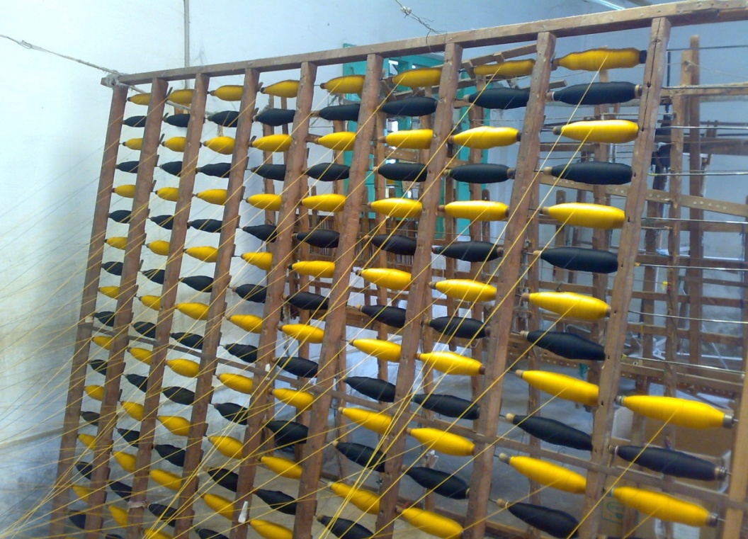
Jute blended yarns being wound on warping Machine
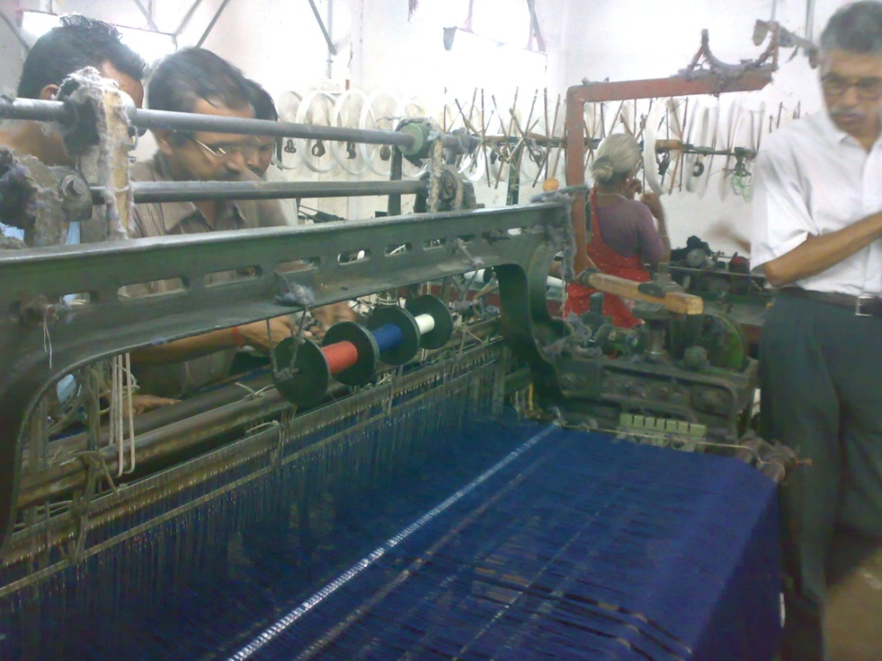
Performance of Jute blended yarns in power looms being inspected
Carpet made in Hand looms using Jute Blended Yarns
Niwar Tapes in Needleloom being produced using Jute blended Yarns

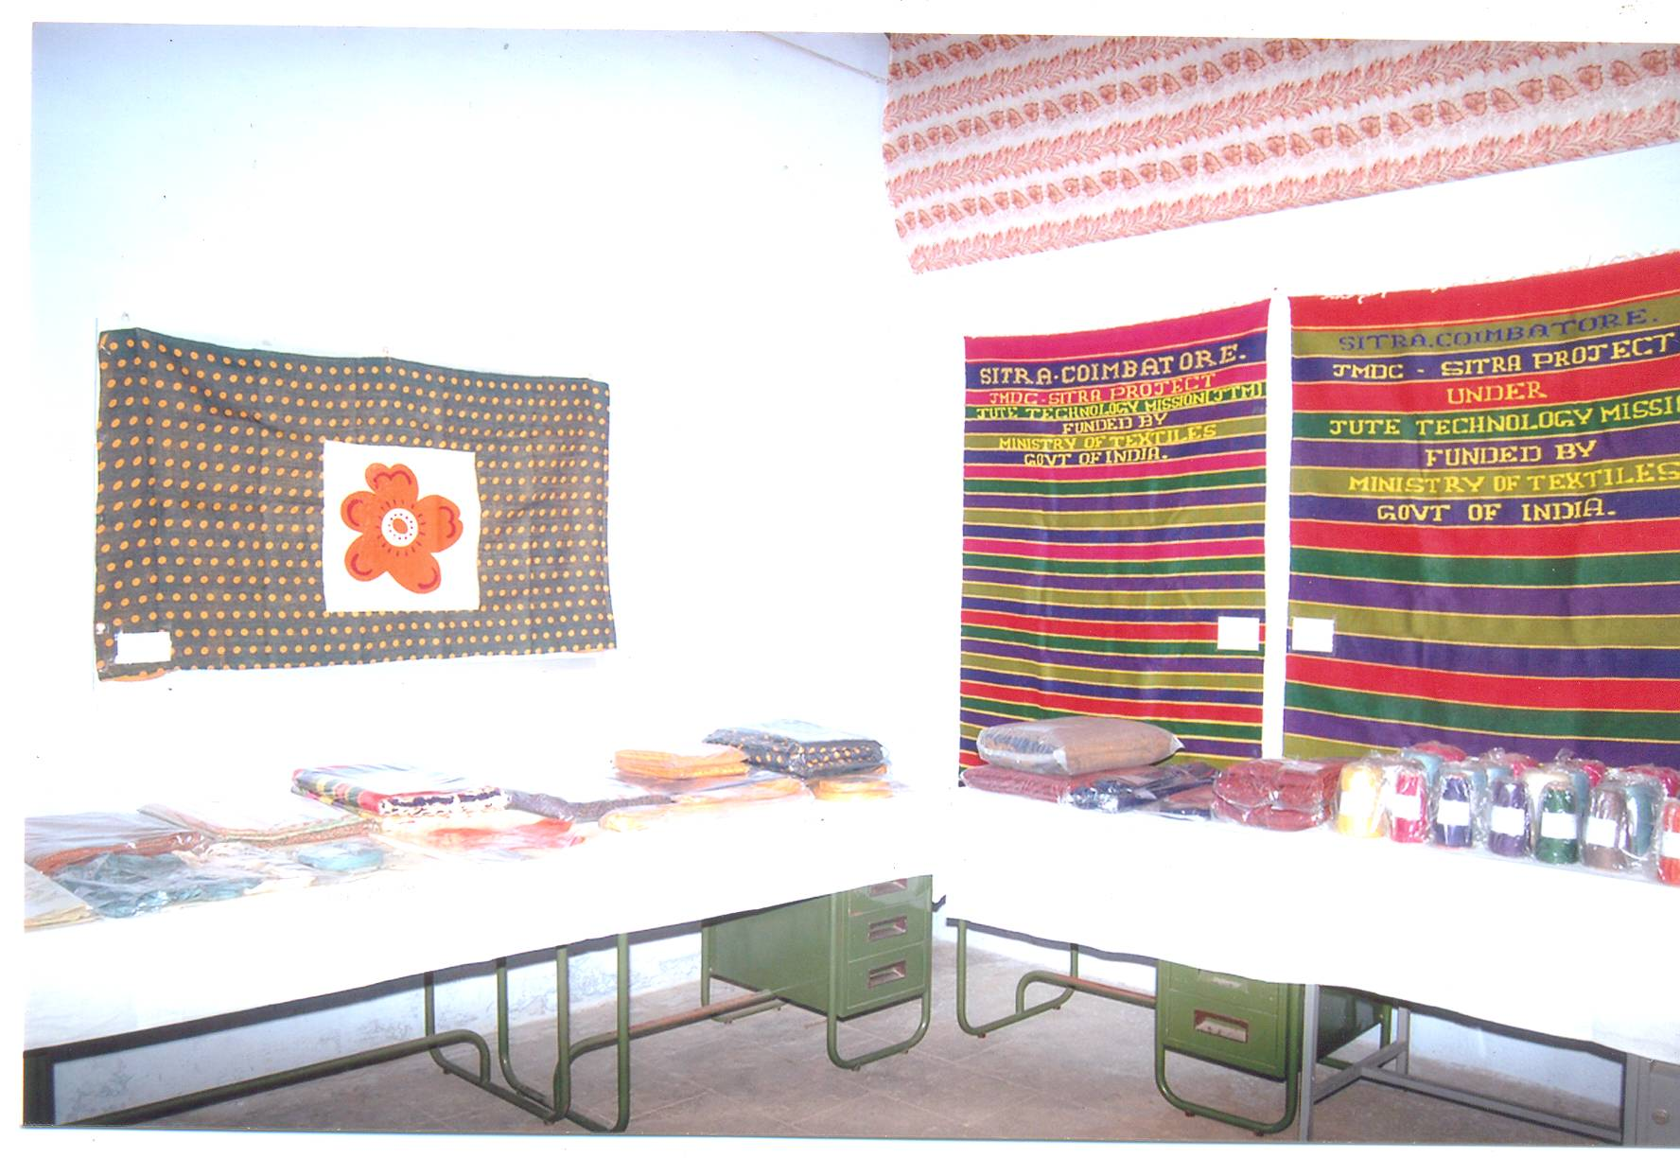

Products displayed made out of Jute blended yarns
Knitting Trials using Jute Blended yarns

Knitting trials were conducted using Jute/acrylic blended yarns. Since Jute/acrylic blended yarns are relatively coarser (4lb/spyndle – 4.3 Ne) only coarse gauge flat knitting machines are found suitable for the purpose. Jute/acrylic blended yarns (4 lb/spyndle) were conditioned and were knitted on a 4 gauge flat knitting machine – Model JL 303. Some sweater fabrics (10 nos.) were knitted using Jute/acrylic blended yarns.
In contract to weaving, in knitting process the yarn has to pass through needle hooks, guides and feeder holes. A lot of yarn bending and sliding takes place on the knitting elements during loop formation. Finally, the yarns lie in the form of small loops in the resultant fabric.
Even after careful handling of the Jute/acrylic blended yarn during flat knitting, the performance of the yarn during knitting was not satisfactory. The major reasons for the relatively poor performance of Jute/acrylic blended yarns on the flat knitting machines are:
- The evenness of the yarn is relatively poor (in comparison with that of 100% cotton or 100% acrylic)
- The bending rigidity of the yarn is relatively high (in comparison with that of 100% cotton or 100% acrylic)
- The pliability of the yarn is relatively inferior (in comparison with that of 100% cotton or 100% acrylic)
- The Jute blended yarn is relatively more hairy (in comparison with that of 100% cotton or 100% acrylic)
- Surface friction of the Jute blended yarn is relatively high (in comparison with that of 100% cotton or 100% acrylic)

Knitting Sweater fabric made using Jute/Acrylic blended yarns
Manufacture of furnishings, upholstery, shawls, niwars, curtain fabrics and secondary apparels in handlooms and powerlooms using the Jute blended yarns manufactured in bulk quantities.

Details of the Products manufactured using Jute blended yarns are as follows.
Products manufactured using Jute/ Viscose blended yarns
Sl.No | Blend Proportion | Product | Constructional particulars
1. | 70% J / 30%V | Made-ups (Placemat) | Warp count : 6 x 2 lbs (1.43 Ne)  Weft count : 6 x 2 lbs (1.43 Ne)  Ends/Inch : 22  Picks/ Inch: 20  Fabric size : 14” x 20”  Weave : Plain  Loom : Powerloom
2. | 50% J / 50%V | Made-ups (Placemat) | Warp count : 6 x 2 lbs (1.43 Ne)  Weft count : 6 x 2 lbs (1.43 Ne)  Ends/Inch : 22  Picks/ Inch: 20  Fabric size: 14” x 20”  Weave : Plain  Loom : Powerloom
3. | 60% J / 40%V | Upholstery  (Curtain cloth) | Warp count : 3 x 2 lbs (2.86 Ne)  Weft count : 3 lbs (5.71 Ne)  Ends/Inch : 22  Picks/ Inch: 26  Fabric size: 1m  Weave : Dobby Design  Loom : Powerloom
Products manufactured using Jute/ Viscose blended yarns (contd)
Sl.No | Blend Proportion | Product | Constructional particulars
4. | 70% J / 30%V | Made-ups  (Table cloth)  - printed | Warp count : 4 x 2 lbs (2.14 Ne)  Weft count : 4lbs (4.28 Ne)  Ends/Inch : 18  Picks/ Inch: 18  Fabric size: 50” x 90”  Weave : Dobby Design  Loom : Powerloom
5. | 70% J / 30%V | Made-ups (Table cloth) | Warp count : 4 x 2 lbs (2.14 Ne)  Weft count : 4 lbs (4.28 Ne)  Ends/Inch : 18  Picks/ Inch: 18  Fabric size : 50” x 90”  Weave : Dobby Design  Loom : Powerloom
6. | 60% J / 40%V | Bed Sheet | Warp count : 3 x 2 lbs (2.83 Ne)  Weft count 3 lbs (5.71 Ne)  Ends/Inch : 22  Picks/ Inch: 26  Fabric size: 60” x 90”  Weave : Plain  Loom : Handloom/Powerloom
7. | 70% J / 30%V | Tapes | Warp count : 4 lbs (4.28 Ne)  Weft count : 4 lbs (4.28 Ne)  Ends/Inch : 30  Picks/ Inch: 28  Fabric size: 1m  Weave : Twill  Loom : Needleloom
Products manufactured using Jute/ Polyester blended yarns
Sl.No | Blend Proportion | Product | Constructional particulars
1. | 70% J / 30%P | Made-ups (Placemat) | Warp count : 6 x 2 lbs (1.43 Ne)  Weft count : 6 x 2 lbs (1.43 Ne)  Ends/Inch : 22  Picks/ Inch: 20  Fabric size : 14” x 20”  Weave : Plain  Loom : Powerloom
2. | 70% J / 30%P | Upholstery  (Curtain cloth) | Warp count : 4 x 2 lbs (2.14 Ne)  Weft count : 4 lbs (4.28 Ne)  Ends/Inch : 18  Picks/ Inch: 18  Width : 1m  Weave : Dobby Design  Loom : Powerloom
3. | 70% J / 30%P | Furnishing Cloth  (Table cloth) | Warp count : 4 x 2 lbs (2.14 Ne)  Weft count : 4 lbs (4.28 Ne)  Ends/Inch : 18  Picks/ Inch: 18  Fabric size: 50” x 90”  Weave : Dobby Design  Loom : Powerloom
4. | 70% J / 30%P | Tapes | Warp count : 4 lbs (4.28 Ne)  Weft count : 4lbs (4.28 Ne)  Ends/Inch : 30  Picks/ Inch: 28  Width: 1”  Weave : Twill  Loom : Needleloom
5. | 70% J / 30%P | Tapes | Warp count : 4lbs (4.28 Ne)  Weft count : 4lbs (4.28 Ne)  Ends/Inch : 16  Picks/ Inch: 16  Width: 1”  Weave : Twill  Loom : Needleloom

Products manufactured using Jute/ Acrylic blended yarns
Sl.No | Blend Proportion | Product | Constructional particulars
1. | 70% J / 30%A | Bedsheet | Warp count : 3 x 2 lbs (2.86 Ne)  Weft count : 6 x 2 lbs (1.43 Ne)  Ends/Inch : 22  Picks/ Inch: 30  Fabric size : 60” x 90”  Weave : Plain  Loom : Handloom /Powerloom
2. | 70% J / 30%A | Shawl | Warp count : 3 x 2 lbs (2.86 Ne)  Weft count : 3 lbs (5.71 Ne)  Ends/Inch : 22  Picks/ Inch: 22  Fabric size: 36” x 72”  Weave : Plain  Loom : Handloom
3. | 70% J / 30%A | Carpet | Warp count : 3 x 2 lbs (2.86 Ne)  Weft count : 3 lbs (5.71 Ne)  Ends/Inch : 7  Picks/ Inch: 30 x 3  Fabric size: 60” x 90”  Weave : Plain  Loom : Handloom
4. | 70% J / 30%A | Made-ups  (Table cloth) | Warp count : 4 x 2 lbs (2.14 Ne)  Weft count : 4lbs (4.28 Ne)  Ends/Inch : 18  Picks/ Inch: 18  Fabric size: 50” x 90”  Weave : Dobby Design  Loom : Powerloom
5. | 70% J / 30%A | Tapes | Warp count : 4 lbs (4.28 Ne)  Weft count : 4lbs (4.28 Ne)  Ends/Inch : 30  Picks/ Inch: 28  Width: 1”  Weave : Twill  Loom : Needleloom

BRAIDING TRIALS USING JUTE BLENDED YARNS
In addition to weaving & knitting, SITRA has conducted some Braiding trials using Jute blended yarns.
Braiding is one of the 4 popular methods of fabric formation. A braid structure is formed by the diagonal intersection of yarns. In braided structure, there are no warp or weft yarns as in the case of woven structures. The process of braiding does not involve shedding or beat up mechanisms. The yarns concerned can be fed directly to the braiding machine from the creel. The feed packages can be either cones or cheeses.
Braiding is more popular for industrial fabrics rather than consumer textiles. About 95% braided fabrics are used for the manufacture of technical textiles. Traditional examples of the braided structures are electrical wires/ cables, hoses, industrial belts and surgical sutures. New application areas for braiding include reinforcement structures of sporting goods like baseball bats, golf clubs, aerospace, automotive parts, etc.
Details pertaining to different types of braiding and their application possibilities are given in Appendix – VII.
Braided cords were made using Jute/viscose, Jute/polyester and Jute/acrylic blended yarns in M/s Meenaatshi Enterprises, Komarapalayam
(Tamil Nadu). The constructional details are given below:

i. Jute/viscose Blended Yarns
(A) Core x Sheath = 4 lb Jute/viscose x 4 lb Jute/viscose
(B) Core x Sheath = 2s cotton x 4 lb Jute/viscose
(C) Core x Sheath = 4 lb Jute/viscose x 2/20^{s} cotton
ii. Jute/polyester Blended Yarns
(A) Core x Sheath = 4 lb Jute/Polyester x 4 lb Jute/Polyester
(B) Core x Sheath = 4x2 lb Jute/polyester x 4x2 lb Jute/polyester
iii. Jute/acrylic Blended Yarns
(A) Core x Sheath = 4 lb Jute/acrylic x 4 lb Jute/acrylic
Shrinkage of Jute blended yarn fabrics (after washing) was found to lie in the range of 5 to 7% (in warp and weft directions). Hence, the dimensional stability of Jute blended yarn fabrics made in this study could be considered as satisfactory.
The braided cords made in this study (using Jute blended yarns) have Tensile strength in the range of 80 to 110 kg with breaking elongation in the range 15 to 20%.
Similarly, the niwar tapes manufactured in the study exhibit Tensile strength in the region of 70 to 85 kg with elongation values of 6.5 to 7%.
The quality of Braided cords & Niwar Tapes could be considered as good.
The various Jute blended yarns samples were evaluated for their colour fastness characteristics. They are given below.
Colour Fastness rating of Jute blended yarns
Sl.No | Description | Colour Fastness 40⁰C |  | Colour Fastness | Dyeing Methods  & Dyes used
 |  | Change in colour | Staining on Cotton | Light Fading  (20 Hours)
1 | J/V (70/30)  4LBS – L Blue | 4 -5 | 4 | 3 - 4 | Cheese Dyeing  (Reactive Dyes)
2 | J/V (70/30)  4/2 LBS - GREY | 4 -5 | 4 - 5 | 3 - 4 | Cheese Dyeing  (Reactive Dyes)
3 | J/V (50/50)  5 lbs - Green | 3 -4 | 3 - 4 | 4 | Manual Dyeing  (Reactive Dyes)
4 | J/V (50/50)  6/2 LBS - Rose | 3 -4 | 3 - 4 | 3 - 4 | Manual Dyeing  (Reactive Dyes)
5 | J/P (70/30)  4/2 LBS – D-Blue | 4 | 3- 4 | 4 | Cheese Dyeing  (Jute -Reactive Dyes) (Polyester – Disperse Dyes)
6 | J/P (70/30)  4 lbs - Maroon | 3 - 4 | 3 - 4 | 3 - 4 | Cheese Dyeing  (Jute -Reactive Dyes) (Polyester – Disperse Dyes)
7 | J/A (70 – 30)  4/2 lbs – D.Blue | 3 -4 | 3 - 4 | 4 | Cheese Dyeing  (Jute –Reactive Dyes Acrylic- Cationic Dyes)
8 | J/A (70/30)  4 LBS – Yellow | 4 | 4 - 5 | 4 | Cheese Dyeing  (Jute –Reactive Dyes Acrylic- Cationic Dyes)
9 | J/A (50/50)  3 LBS – yellow | 4 | 4 - 5 | 4 | Cheese Dyeing  (Jute –Reactive Dyes Acrylic- Cationic Dyes)

Fastness Rating: Light Fastness
Colour Fastness to Washing AATCC (2 – 9) Scale
5* - Excellent – Negligible Staining 9* : Very High Light Fastness
4* - Good – Slight Staining 2* : Very Low Light Fastness
3* - Fair – Noticeable Staining
2* - Poor – Considerable Staining
1* - Very Poor – Severe Staining
Braided Cords being manufactured using Jute blended yarns

Quality Attributes of Braided Cords made using Jute Blended Yarns
S.No | Particulars | Jute/Viscose | Jute/Polyester | Jute/Acrylic
1 | Proportion | 70/30 | 70/30 | 70/30
2 | Count
 | Core Yarn | 4 x 2 lbs | 4 x 2 lbs | 4 x 2 lbs
 | Sheath Yarn | 4 x 2 lbs | 4 x 2 lbs | 4 x 2 lbs
3 | Cord Dia | 6 mm | 6 mm | 6 mm
4 | Number of Threads
 | In Core | 20 | 30 | 30
 | In Sheath | 32 | 20 | 20
5 | Maximum load in Kg | 117.55 | 113.71 | 128.22
6 | Tensile Strain at Max. Load % | 14.00 | 18.40 | 20.40

Quality Attributes of Niwar Tapes made using Jute Blended Yarns

S.No | Particulars | Jute/Viscose | Jute/Polyester | Jute/Acrylic
1 | Proportion | 70/30 | 70/30 | 70/30
2 | Count
 | Warp | 4 lbs | 4 lbs | 4 lbs
 | Weft | 4 lbs | 4 lbs | 4 lbs
3 | Ends per Inch | 30 | 30 | 30
4 | Picks per Inch | 28 | 28 | 28
5 | Width in Inch | 1 | 1 | 1
6 | Weave | Twill | Twill | Twill
7 | Tensile Strength in Kg | 72.29 | 87.93 | 66.85
8 | Elongation % | 6.33 | 8.81 | 7.81
7 Results & Outcomes of R & D Activities

The results and outcomes of R&D project was elaborately explained in earlier Chapter No: 6.
- It was concluded that blending Man-made fibre in cut staple form with Jute in Jute spinning system does not yield acceptable performance and yarn quality levels.
- MMF Tops are preferable to blend with Jute in Jute spinning system.
- Blending of Jute sliver and MMF sliver in drawing frame is not recommended due to blend variation in the final product and additional machinery requirement for the preparation of MMF sliver.
- Blending of Jute sliver with MMF Tops (Variable cut length) in finisher card of Jute spinning system is more suitable to manufacture Jute blended yarns.
- Four drawing passages (Screw Gill Drawing) in the process are ideal to manufacture grists 4 lbs and finer lbs in ring spinning system.
- Three drawing passages (Rotary Gill and Screw Gill Drawing) in the process are enough to manufacture 5 lbs and 6 lbs in flyer spinning system.
- Modifications were carried out at the finisher card feeding area to facilitate feeding of MMF Tops with Jute breaker card sliver.
- Finer variety of Jute (TD 4 and TD 5) is recommended while spinning 2 lb, 3 lb and 4 lb Jute blended yarns.
- Working performance was found good while processing Jute with finer denier (3, 4 denier) MMF Tops.
- Jute mills could consider for manufacturing Jute blended yarns / products with the available existing infrastructure. Jute blended yarns can be manufactured by slight modifications, settings and adjustments in the existing jute machinery.
- The major quality attributes of Jute blended yarns spun in Flyer and Ring spinning system are evaluated which is not studied in the previous research studies especially for Jute blended yarns.
- Bulk trails on Jute/Polyester and Jute/Acrylic blended yarns are successfully carried out in Jute spinning system.
- Braided cords were made using Jute/Viscose, Jute/Polyester and Jute/Acrylic blended yarns.
- Knitted trails were conducted using Jute/Acrylic blended yarns on flat knitting machines and performance on the yarn during knitting was not satisfactory.
- The economic viability of products made using Jute blended yarns was worked out.
- A dissemination workshop was conducted at Kolkata jointly by IJT & SITRA on 26th March 2010.
- As an offshoot of the Kolkata workshop, SITRA has supplied around 70 kgs of Jute/Viscose & Jute/Polyester blended yarns (Single as well as
ply – Grey and Dyed yarns) to Mr.Sushil Khaitan, M/s. Ashoka Exports, Kolkata for Product development & Performance appraisal.
- The products developed by M/s Ashoka Exports are given in
Appendix – V. The handicraft products such as shopping bags, designer bags, purse, gift articles, folders etc. could be made by design development programme on Jute blended products.

8 Product / Process Standardization
The products / process standardization of the R&D project was elaborately explained in earlier chapter No: 6 & 7.
Product Standardization
- Raw material
Jute
- TD4 grade is recommended to produce finer Jute blended yarns (4 lbs & finer).
- TD5 grade is recommended to produce Coarser Jute blended yarns (5 lbs & 6 lbs).
MMF
- Tops (Variable cut length) of 3.0 denier is recommended to mix with Jute for finer counts (2 lbs, 3lbs & 4 lbs).
- Tops (Variable cut length) of 4.0 or 5.0 denier is recommended to mix with Jute for coarser counts (5 lbs and coarser) to manufacture table cloth & made – ups.

- Process Standardisation
- MMF tops blended with breaker card Jute sliver in the finisher card.
- 4 passages drawing process is recommended for producing finer lbs of Jute blended yarns in ring spinning.
- For manufacturing 5 lbs and coarser lbs Jute blended yarns, 3 passages drawing process is ideal.

9 Report on Pilot Scale and Bulk Scale Trails
Pilot scale trials were conducted in 2 Jute mills
- M/s Sudha Jute Spinning Mills, Eddapadi, Salem
- M/s Shree Vijayalakshmi Jute Mills,
Rajam, Sri Kakulam District, Andra Pradesh
- Jute blended with slivers of appropriate linear density prepared from cut – staple fibres (MMF) of different denier and cut lengths in the finisher card of Jute spinning system. Bulk of Manmade fibres were removed as waste in the finisher card and finisher card sliver was found to have only minimum quantity of MMF.
- Homogeneous blending of MMF with Jute could not be obtained.
- High level of end breakages were noticed in Flyer spinning.
- Blend variation was noticed in the final stage.
- Yarn quality was not satisfactory.
- Alternatively other methods of trails in Flyer spinning system using MMF in the form of Tops was conducted in M/s Shree Vijayalakshmi Jute Mills, Rajam (A.P).
- MMF Tops were blended with Jute in finisher card and processed through Jute spinning system and manufactured 5 lbs & 6 lbs. The working performance & yarn quality were found satisfactory.

Bulk trails on Jute blended yarns were conducted in 2 Jute mills.
- M/s Shree Vijayalakshmi Jute Mills,
Rajam, Sri Kakulam District, Andra Pradesh.
- M/s Gloster Jute Mills,
Howrah District, West Bengal.
- Jute blended yarns 5 lbs & 6 lbs were manufactured in Flyer spinning system with 3 passages Draw frames.
- 4 lbs & finer were manufactured in Ring spinning system.
- For free unwinding of MMF Tops and proper feeding with breaker card Jute sliver in the back side of Finisher card feeding arrangement was made in the Finisher card (freely rotating polished rod/pipe supported by stands on both side).
- Alternatively MMF Tops were converted in the form of sliver collected in cans in Drawing frame and processed with Breaker card Jute sliver in Finisher card. This may be considered while processing finer counts (2 lbs & 3 lbs) of Jute blended yarn. By this method linear density of MMF Tops could be adjusted.
- The quality of the fleece observed at the delivery side conductor and settings corrected between feed roller & feed stripper and also the roller settings were corrected in drawing.
- Waste droppings corrected in the finisher card by adjusting the setting between cylinder and rollers (Worker & Stripper).
- Finisher card sliver weight CV% was maintained below 5.0.
- Finisher drawing sliver weight was maintained 80 lbs/spyndle and CV was below 4.0%.
- The finisher drawing sliver crimp was optimized at the delivery side for free opening in the subsequent process (drafting zone) without sliver breaks at the creel.
- Jute blended yarn weight CV% was maintained below 4% and strength CV% below 20% in the case of Jute/Viscose and Jute/Acrylic blended yarns where as it was slightly higher in Jute/Polyester blended yarn
- 5 lbs / 6 lbs Jute blended yarns manufactured in Flyer spinning (slip draft) and Flyer speed was 3700 rpm.
- 2 lbs / 3 lbs & 4 lbs Jute blended yarns made in Ring spinning with apron drafting and the spindle speed was 4900 rpm.
- Jute/Polyester blends working performance was affected in Ring spinning due to low moisture content in polyester fibre resulting improper drafting in the drafting zone causing yarn breakages.
- End breakages in Flyer spinning /Ring spinning were between 65 – 75 / 100 spl hrs in the case of Jute/Viscose and Jute/Acrylic blends. Whereas the breakage rate was 90 – 95 / 100 spl hrs in the case of Jute/Polyester blend.
- Total draft in Flyer spinning /Ring spinning is recommended below 25 to achieve better working performance as well as quality of Jute blended yarns.
- Jute/Polyester yarn quality was slightly inferior compare to Jute/Viscose and Jute/Acrylic blended yarns.
- Breakages in winding machine and twisting machine (2 ply) were high while processing Jute/Polyester blended yarns.
- Details of the deliverables at the end of the project are given in Appendix – VI.
- Efficiency in winding and twisting machine (2 ply) was affected while processing Jute/Polyester blended yarns.
- Hairiness could be reduced 10 – 15% in winding by applying wax treatment to Jute blended yarns and 20 – 25% in fabrics by adding singeing process.
10 Cost Analysis / Cost Effectiveness Study Report
Cost of manufacturing (COM) JDPs using jute blended yarns was worked out for a number of JDPs produced in this project and the same was compared with the COM of corresponding conventional products made using Cotton / Acrylic / Polyester. Cost comparison between the products manufactured using Jute blended yarns and similar products manufactured using other fibres was made.
SITRA has already submitted a performa to NJB and JC’s office for collection of necessary data on Jute blended yarns required for cost comparison.
The economic viability of products made using Jute blended yarns was worked out. The products covered are
- Made – ups (Placemat) using J/V blended yarns as against Made – ups made using 100% Cotton.
- Upholstery (Curtain Cloth) using J/V blended yarns as against Upholstery made using 100% Cotton.
- Table cloth using J/V yarns as against
table cloth made using 100% Cotton.
- Bed sheets using J/V yarns as against
Bed sheets made using 100% Cotton yarns.
- Niwar Tapes using J/V blended yarns as against
Tapes made using 100% Cotton.
- Upholstery cloth using J/P yarns as against
Upholstery cloth made using 100% Cotton.
- Furnishing cloth using J/P yarns as against
Furnishing cloth made using 100% Cotton.
- Niwar Tapes using J/P yarns as against
Niwar Tapes made using 100% Polyester.
- Bed sheets using J/A yarns as against
Bed sheets made using Cotton/Acrylic yarns
and 100% Cotton yarns.
- Shawls using J/A yarns as against shawls
made using 100% Acrylic yarns.
- Braided Cords using J/V & J/P yarns as against
Braided cords made using 100% cotton yarns.
- Carpets using J/A yarns as against
Carpets made using Cotton/Acrylic yarns
- Table cloth using J/A blended yarns as against
Table cloth made using 100% Cotton yarns.

The details are given below.

Cost of Manufacturing of Made-Ups (Placemat) Using
Jute/Viscose blended yarns & Cotton yarns
S.No | Particulars | Jute / Viscose  (70/30) |  | Cotton  (100%)
1 | Fibre  Jute  Viscose | TD – 5  3 D (Variable cut length) |  | ***  ***
2 | Count  Warp  Weft | 6 x 2 lb (1.43 Ne)  6 x 2 lb (1.43 Ne) |  | 2/20 Ne  2/20 Ne & 2 Ne
3 | Construction  Ends / Inch  Picks / Inch  Fabric size  Weave  Loom | 22  20  14” x 20”  Plain  Power loom |  | 90  2/20s-5 & 2s-8x5  14” x 20”  Plain  Power loom
4 | Fibre Price in Rs/Kg  Jute  Viscose (Tops)  J/V (75/25)  J/V @ 92% Real | 56  160  82  89 |  | ***  ***  ***  ***
5 | Yarn Conversion cost in Rs/Kg | 28 |  | ***
6 | Total yarn cost in Rs/Kg | 117 |  | 2/20s – 170, 2s-82
7 | Yarn cheese Dyeing cost in Rs/Kg  Light colour  Medium colour  Dark colour | 70  80  90 |  | 70  80  90
8 | Fabric weight in g/piece | 130 |  | 130 (Warp 2/20s –40)  Weft 2/20s-2, 2s-88
9 | Conversion cost in Rs/Piece  a. Wages & Salaries  b. Power  c. Spares & Maintenance  d. Administrative Expenses  e. Interest  f. Depreciation | 4.5 |  | 9.0
 |  | Rs  2.25  0.50  0.40  0.35  0.50  0.50 | %  7.63  1.69  1.36  1.19  1.69  1.69 | Rs  6.50  0.55  0.45  0.35  0.60  0.55 | %  19.70  1.67  1.36  1.06  1.82  1.67
10 | Cost of the Fabric in Rs/Piece  Yarn cost  Dyeing cost (Medium)  Fabric conversion | 15.00  10.00  4.50 |  | 14.00  10.00  9.00
11 | Fabric Manufacturing cost in Rs/Piece | 29.50 |  | 33.00

Cost of Manufacturing of Upholstery (Curtain Cloth) Using
Jute/Viscose blended yarns & Cotton yarns
S.No | Particulars | Jute / Viscose  (60/40) |  | Cotton  (100%)
1 | Fibre  Jute  Viscose | TD – 5  3 D (Variable cut length) |  | ***  ***
2 | Count  Warp  Weft | 3 x 2 lb (2.86 Ne)  3 lb (5.71Ne) |  | 2/20 Ne  2/20 Ne
3 | Construction  Ends / Inch  Picks / Inch  Fabric size  Weave  Loom | 22  26  1 m x 1 m  Dobby Design  Power loom |  | 64  58  1 m x 1m  Dobby Design  Power loom
4 | Fibre Price in Rs/Kg  Jute  Viscose (Tops)  J/V (65/35)  J/V @ 92% Real | 56  160  92  100 |  | ***  ***  ***  ***
5 | Yarn Conversion cost in Rs/Kg | 55 |  | ***
6 | Total yarn cost in Rs/Kg | 155 |  | 170
7 | Yarn cheese Dyeing cost inRs/Kg  Light colour  Medium colour  Dark colour | 70  80  90 |  | 70  80  90
8 | Fabric weight in g/piece | 300 |  | 300
9 | Conversion cost in Rs/Piece  a. Wages & Salaries  b. Power  c. Spares & Maintenance  d. Administrative Expenses  e. Interest  f. Depreciation | 12 |  | 21
 |  | Rs  5.80  1.25  1.20  1.15  1.25  1.35 | %  6.99  1.51  1.45  1.39  1.51  1.63 | Rs  13.20  1.60  1.50  1.55  1.45  1.70 | %  13.75  1.67  1.56  1.61  1.51  1.77
10 | Cost of the Fabric in Rs/Piece  Yarn cost  Dyeing cost (Medium)  Fabric conversion | 47.00  24.00  12.00 |  | 51.00  24.00  21.00
11 | Fabric Manufacturing cost in Rs/Piece | 83.00 |  | 96.00

Cost of Manufacturing of Table Cloth using
Jute/Viscose blended yarns & Cotton yarns
S.No | Particulars | Jute / Viscose  (70/30) |  | Cotton  (100%)
1 | Fibre  Jute  Viscose | TD – 5  3 D (Variable cut length) |  | ***  ***
2 | Count  Warp  Weft | 4 x 2 lb (2.14 Ne)  4 lb (4.28Ne) |  | 2/20 Ne  2/20 Ne
3 | Construction  Ends / Inch  Picks / Inch  Fabric size  Weave  Loom | 18  18  50” x 90”  Dobby Design  Power loom |  | 64  62  50” x 90”  Dobby Design  Power loom
4 | Fibre Price in Rs/Kg  Jute  Viscose (Tops)  J/V (75/25)  J/V @ 92% Real | 56  160  82  89 |  | ***  ***  ***  ***
5 | Yarn Conversion cost in Rs/Kg | 44 |  | ***
6 | Total yarn cost in Rs/Kg | 133 |  | 170
7 | Yarn cheese Dyeing cost in Rs/Kg  Light colour  Medium colour  Dark colour | 70  80  90 |  | 70  80  90
8 | Fabric weight in g/piece | 900 |  | 900
9 | Conversion cost in Rs/Piece  a. Wages & Salaries  b. Power  c. Spares & Maintenance  d. Administrative Expenses  e. Interest  f. Depreciation | 23 |  | 50
 |  | Rs  9.40  3.10  2.70  2.50  2.70  2.60 | %  4.37  1.44  1.26  1.16  1.26  1.21 | Rs  32.00  4.25  3.50  3.25  3.50  3.50 | %  11.64  1.55  1.27  1.18  1.27  1.27
10 | Cost of the Fabric in Rs/Piece  Yarn cost  Dyeing cost (Medium)  Fabric conversion | 120.00  72.00  23.00 |  | 153.00  72.00  50.00
11 | Fabric Manufacturing cost in Rs/Piece | 215.00 |  | 275.00
Cost of Manufacturing of Table Cloth (Printed) using
Jute/Viscose blended yarns & Cotton yarns
S.No | Particulars | Jute / Viscose  (70/30) |  | Cotton  (100%)
1 | Fibre  Jute  Viscose | TD – 5  3 D (Variable cut length) |  | ***  ***
2 | Count  Warp  Weft | 4 x 2 lb (2.14 Ne)  4 lb (4.28Ne) |  | 2/20 Ne  2/20 Ne
3 | Construction  Ends / Inch  Picks / Inch  Fabric size  Weave  Loom | 18  18  50” x 90”  Dobby Design  Power loom |  | 64  62  50” x 90”  Dobby Design  Power loom
4 | Fibre Price in Rs/Kg  Jute  Viscose (Tops)  J/V (75/25)  J/V @ 92% Real | 56  160  82  89 |  | ***  ***  ***  ***
5 | Yarn Conversion cost in Rs/Kg | 44 |  | ***
6 | Total yarn cost in Rs/Kg | 133 |  | 170
7 | Fabric weight in g/piece | 900 |  | 900
8 | Conversion cost in Rs/Piece  a. Wages & Salaries  b. Power  c. Spares & Maintenance  d. Administrative Expenses  e. Interest  f. Depreciation | 22 |  | 50
 |  | Rs  9.20  3.10  2.30  2.40  2.50  2.50 | %  4.55  1.53  1.14  1.19  1.24  1.24 | Rs  32.00  4.25  3.50  3.25  3.50  3.50 | %  12.17  1.62  1.33  1.24  1.33  1.33
10 | Cost of the Fabric in Rs/Piece  Yarn cost  Bleaching & printing cost Fabric conversion | 120.00  60.00  22.00 |  | 153.00  60.00  50.00
11 | Fabric Manufacturing cost in Rs/Piece | 202.00 |  | 263.00

Cost of Manufacturing of Bedsheets Using
Jute/Viscose blended yarns & Cotton yarns
S.No | Particulars | Jute / Viscose (60/40) |  |  |  | Cotton(100%)
1 | Fibre  Jute  Viscose | TD – 5  3 D (Variable cut length) |  |  |  | ***  ***
2 | Count  Warp  Weft | 3 x 2 lb (2.86 Ne)  3 lb (5.71 Ne) |  |  |  | 2/20 Ne  2/20 Ne
3 | Construction  Ends / Inch  Picks / Inch  Fabric size  Weave  Loom | 22  26  60” x 90”  Plain  Handloom / Power loom |  |  |  | 64  60  60” x 90”  Plain  Handloom / Power loom
4 | Fibre Price in Rs/Kg  Jute  Viscose (Tops)  J/V (65/35)  J/V @ 92% Real | 56  160  92  100 |  |  |  | ***  ***  ***  ***
5 | Yarn Conversion cost inRs/Kg | 55 |  |  |  | ***
6 | Total yarn cost in Rs/Kg | 155 |  |  |  | 170
7 | Yarn cheese Dyeing cost in Rs/Kg  Light colour  Medium colour  Dark colour | 70  80  90 |  |  |  | 70  80  90
8 | Fabric weight in g/piece | 1050 |  |  |  | 1050
9 | Conversion cost in Rs/Piece  - Wages & Salaries  - Power  - Spares & Maintenance  - Admn. Expenses  - Interest  - Depreciation | Handloom |  | Powerloom |  | Handloom |  | Powerloom
 |  | 57 |  | 29 |  | 110 |  | 47
 |  | Rs  49.40  1.40  1.50  1.50  1.70  1.50 | %  16.25  0.46  0.49  0.49  0.56  0.49 | Rs  14.00  3.22  2.22  2.22  2.50  4.84 | %  5.07  1.17  0.80  0.80  0.91  1.75 | Rs  100.00  1.40  2.60  2.60  1.70  1.70 | %  27.62  0.39  0.72  0.72  0.47  0.47 | Rs  29.00  3.86  3.16  3.26  2.56  5.16 | %  9.35  1.25  1.02  1.05  0.83  1.66
10 | Cost of the Fabric in Rs/Piece  Yarn cost  Dyeing cost (Medium)  Fabric conversion | 163.00  84.00  57.00 |  | 163.00  84.00  29.00 |  | 179.00  84.00  110.00 |  | 179.00  84.00  47.00
11 | Fabric Manufacturing cost in Rs/Piece | 304 |  | 276 |  | 373 |  | 310
Cost of Manufacturing of Niwar Tapes
using Jute/Viscose blended yarns & Cotton yarns
S.No | Particulars | Jute / Viscose (70/30) |  | Cotton(100%)
1 | Fibre  Jute  Viscose(Tops) | TD – 5  3 D (Variable cut length) |  | ***  ***
2 | Count  Warp  Weft | 4 lb (4.28 Ne)  4 lb (4.28 Ne) |  | 2/20 Ne  2/20 Ne
3 | Construction  Ends / Inch  Picks / Inch  Width  Weave  Loom | 30  28  1”  Twill  Needle loom |  | 68  60  1”  Twill  Needle loom
4 | Fibre Price in Rs/Kg  Jute  Viscose (Tops)  J/V (75/25)  J/V @ 92% Real | 56  160  82  89 |  | ***  ***  ***  ***
5 | Yarn Conversion cost in Rs/Kg | 44 |  | ***
6 | Total yarn cost in Rs/Kg | 133 |  | 170
7 | Tape dyeing cost /metre | 0.50 |  | 0.50
8 | Tape weight- grams/metre | 8 |  | 8
9 | Conversion cost in Rs/metre  a. Wages & Salaries  b. Power  c. Spares & Maintenance  d. Administrative Expenses  e. Interest  f. Depreciation | 0.25 |  | 0.35
 |  | Rs  0.14  0.02  0.03  0.02  0.02  0.02 | %  7.73  1.10  1.66  1.10  1.10  1.10 | Rs  0.21  0.04  0.03  0.02  0.02  0.03 | %  9.50  1.81  1.36  0.90  0.90  1.36
10 | Cost of the Tape in Rs/metre  Yarn cost  Dyeing cost (Medium)  Tape conversion | 1.06  0.50  0.25 |  | 1.36  0.50  0.35
11 | Tape Manufacturing cost in Rs/metre (Dyed) | 1.81 |  | 2.21
12 | Tape Manufacturing cost in Rs/metre (Grey) | 1.31 |  | 1.71

Cost of Manufacturing of Upholstery (Curtain Cloth) using
Jute/Polyester blended yarns & Cotton yarns
S.No | Particulars | Jute / Polyester  (70/30) |  | Cotton  (100%)
1 | Fibre  Jute  Polyester | TD – 5  3 D (Variable cut length) |  | ***  ***
2 | Count  Warp  Weft | 4 x 2 lb (2.14 Ne)  4 lb (4.28 Ne) |  | 2/20 Ne  2/20 Ne
3 | Construction  Ends / Inch  Picks / Inch  Fabric size  Weave  Loom | 18  18  1 m x 1 m  Dobby Design  Power loom |  | 64  58  1 m x 1 m  Dobby Design  Power loom
4 | Fibre Price in Rs/Kg  Jute  Polyester (Tops)  J/P (75/25)  J/P @ 92% Real | 56  140  77  84 |  | ***  ***  ***  ***
5 | Yarn Conversion cost in Rs/Kg | 44 |  | ***
6 | Total yarn cost in Rs/Kg | 128 |  | 170
7 | Yarn cheese Dyeing cost in Rs/Kg  Light colour  Medium colour  Dark colour | 120  130  140 |  | 70  80  90
8 | Fabric weight in g/piece | 300 |  | 300
9 | Conversion cost in Rs/Piece  a. Wages & Salaries  b. Power  c. Spares & Maintenance  d. Administrative Expenses  e. Interest  f. Depreciation | 10 |  | 21
 |  | Rs  4.00  1.25  1.15  1.15  1.20  1.25 | %  4.60  1.44  1.32  1.32  1.38  1.44 | Rs  13.20  1.60  1.50  1.55  1.45  1.70 | %  13.75  1.67  1.56  1.61  1.51  1.77
10 | Cost of the Fabric in Rs/Piece  Yarn cost  Dyeing cost (Medium)  Fabric conversion | 38.00  39.00  10.00 |  | 51.00  24.00  21.00
11 | Fabric Manufacturing cost in Rs/Piece | 87.00 |  | 96.00

Cost of Manufacturing of Furnishing Cloth using
Jute/Polyester blended yarns & Cotton yarns
S.No | Particulars | Jute / Polyester  (70/30) |  | Cotton  (100%)
1 | Fibre  Jute  Polyester | TD – 5  3 D (Variable cut length) |  | ***  ***
2 | Count  Warp  Weft | 4 x 2 lb (2.14 Ne)  4 lb (4.28 Ne) |  | 2/20 Ne  2/20 Ne
3 | Construction  Ends / Inch  Picks / Inch  Fabric size  Weave  Loom | 18  18  50” x 90”  Dobby Design  Power loom |  | 64  62  50” x 90”  Dobby Design  Power loom
4 | Fibre Price in Rs/Kg  Jute  Polyester (Tops)  J/P (75/25)  J/P @ 92% Real | 56  140  77  84 |  | ***  ***  ***  ***
5 | Yarn Conversion cost in Rs/Kg | 44 |  | ***
6 | Total yarn cost in Rs/Kg | 128 |  | 170
7 | Yarn cheese Dyeing cost in Rs/Kg  Light colour  Medium colour  Dark colour | 120  130  140 |  | 70  80  90
8 | Fabric weight in g/piece | 900 |  | 900
9 | Conversion cost in Rs/Piece  a. Wages & Salaries  b. Power  c. Spares & Maintenance  d. Administrative Expenses  e. Interest  f. Depreciation | 23 |  | 50
 |  | Rs  9.20  3.10  2.30  2.40  2.50  2.50 | %  3.61  1.22  0.90  0.94  0.98  0.98 | Rs  32.00  4.25  3.50  3.25  3.50  3.50 | %  11.64  1.55  1.27  1.18  1.27  1.27
10 | Cost of the Fabric in Rs/Piece  Yarn cost  Dyeing cost (Medium)  Fabric conversion | 115.00  117.00  23.00 |  | 153.00  72.00  50.00
11 | Fabric Manufacturing cost in Rs/Piece | 255.00 |  | 275.00

Cost of Manufacturing of Table Cloth (Printed) using
Jute/Polyester blended yarns & Cotton yarns
S.No | Particulars | Jute / Polyester  (70/30) |  | Cotton  (100%)
1 | Fibre  Jute  Polyester | TD – 5  3 D (Variable cut length) |  | ***  ***
2 | Count  Warp  Weft | 4 x 2 lb (2.14 Ne)  4 lb (4.28 Ne) |  | 2/20 Ne  2/20 Ne
3 | Construction  Ends / Inch  Picks / Inch  Fabric size  Weave  Loom | 18  18  50” x 90”  Dobby Design  Power loom |  | 64  62  50” x 90”  Dobby Design  Power loom
4 | Fibre Price in Rs/Kg  Jute  Polyester (Tops)  J/P (75/25)  J/P @ 92% Real | 56  140  77  84 |  | ***  ***  ***  ***
5 | Yarn Conversion cost in Rs/Kg | 44 |  | ***
6 | Total yarn cost in Rs/Kg | 128 |  | 170
7 | Fabric Bleaching & Printing Cost/Piece | 70 |  | 60
8 | Fabric weight in g/piece | 900 |  | 900
9 | Conversion cost in Rs/Piece  a. Wages & Salaries  b. Power  c. Spares & Maintenance  d. Administrative Expenses  e. Interest  f. Depreciation | 22 |  | 50
 |  | Rs  9.20  3.10  2.30  2.40  2.50  2.50 | %  4.44  1.50  1.11  1.16  1.21  1.21 | Rs  32.00  4.25  3.50  3.25  3.50  3.50 | %  12.17  1.62  1.33  1.24  1.33  1.33
10 | Cost of the Fabric in Rs/Piece  Yarn cost  Dyeing cost (Medium)  Fabric conversion | 115.00  70.00  22.00 |  | 153.00  60.00  50.00
11 | Fabric Manufacturing cost in Rs/Piece | 207.00 |  | 263.00

Cost of Manufacturing of Niwar Tapes
using Jute/Polyester blended yarns & Cotton yarns
S.No | Particulars | Jute / Polyester (70/30) |  | Cotton(100%)
1 | Fibre  Jute  Polyester | TD – 5  3 D (Variable cut length) |  | ***  ***
2 | Count  Warp  Weft | 4 lb (4.28 Ne)  4 lb (4.28 Ne) |  | 2/20 Ne  2/20 Ne
3 | Construction  Ends / Inch  Picks / Inch  Width  Weave  Loom | 30  28  1”  Twill  Needle loom |  | 68  60  1”  Twill  Needle loom
4 | Fibre Price in Rs/Kg  Jute  Polyester (Tops)  J/P (75/25)  J/P @ 92% Real | 56  140  77  84 |  | ***  ***  ***  ***
5 | Yarn Conversion cost in Rs/Kg | 44 |  | ***
6 | Total yarn cost in Rs/Kg | 128 |  | 170
7 | Tape weight- grams/metre | 8 |  | 8
8 | Conversion cost in Rs/metre  a. Wages & Salaries  b. Power  c. Spares & Maintenance  d. Administrative Expenses  e. Interest  f. Depreciation | 0.25 |  | 0.35
 |  | Rs  0.14  0.02  0.03  0.02  0.02  0.02 | %  6.76  0.97  1.45  0.97  0.97  0.97 | Rs  0.21  0.04  0.03  0.02  0.02  0.03 | %  9.50  1.81  1.36  0.90  0.90  1.36
9 | Cost of the Tape in Rs/metre  Yarn cost  Dyeing cost (Medium)  Tape conversion | 1.02  0.80  0.25 |  | 1.36  0.50  0.35
10 | Tape Manufacturing cost in Rs/metre (Dyed) | 2.07 |  | 2.21
11 | Tape Manufacturing cost in Rs/metre (Grey) | 1.27 |  | 1.71

Cost of Manufacturing of Niwar Tapes
using Jute/Polyester blended yarns & Polyester
S.No | Particulars | Jute / Polyester (70/30) |  | Polyester(100%)
1 | Fibre  Jute  Polyester | TD – 5  3 D (Variable cut length) |  | ***  ***
2 | Count  Warp  Weft | 4 lb (4.28 Ne)  4 lb (4.28 Ne) |  | 300 D  300 D
3 | Construction  Ends / Inch  Picks / Inch  Width  Weave  Loom | 16  16  1”  Twill  Needle loom |  | 72  60  1”  Twill  Needle loom
4 | Fibre Price in Rs/Kg  Jute  Polyester (Tops)  J/P (75/25)  J/P @ 92% Real | 56  140  77  84 |  | ***  ***  ***  ***
5 | Yarn Conversion cost in Rs/Kg | 44 |  | ***
6 | Total yarn cost in Rs/Kg | 128 |  | 170
7 | Tape dyeing cost in Rs/metre | 0.80 |  | 0.60
8 | Tape weight – grams/metre | 8 |  | 8
9 | Conversion cost in Rs/metre  a. Wages & Salaries  b. Power  c. Spares & Maintenance  d. Administrative Expenses  e. Interest  f. Depreciation | 0.25 |  | 0.50
 |  | Rs  0.14  0.02  0.03  0.02  0.02  0.02 | %  6.76  0.97  1.45  0.97  0.97  0.97 | Rs  0.30  0.05  0.04  0.03  0.04  0.04 | %  12.61  2.10  1.68  1.26  1.68  1.68
10 | Cost of the Tape in Rs/metre  Yarn cost  Dyeing cost (Medium)  Tape conversion | 1.02  0.80  0.25 |  | 1.28  0.60  0.50
11 | Tape Manufacturing cost in Rs/metre (Dyed) | 2.07 |  | 2.38
12 | Tape Manufacturing cost in Rs/metre (Grey) | 1.27 |  | 1.78

Cost of Manufacturing of Braided cords using
Jute/Polyester blended yarns & Cotton yarns
S.No | Particulars | Jute / Polyester (70/30) |  | Cotton(100%)
1 | Fibre  Jute  Polyester (Tops) | TD – 5  3 D (Variable cut length) |  | ***
2 | Count  Core yarn  Sheathe yarn | 4 lb (4.28 Ne)  4 lb (4.28 Ne) |  | 2/10 Ne  2/20 Ne
3 | Construction  Core yarn  Sheathe yarn | 20 threads  32 threads |  | 30 threads  64 threads
4 | Dia | 6 mm |  | 6 mm
5 | Machine | Braiding Machine |  | Braiding Machine
6 | Fibre Price in Rs/Kg  Jute  Polyester (Tops)  J/P (75/25)  J/P @ 92% Real | 56  140  77  84 |  | ***  ***  ***  ***
7 | Yarn Conversion cost in Rs/Kg | 44 |  | ***
8 | Total yarn cost in Rs/Kg | 128.00 |  | 2/20s – 170  2/10s - 105
10 | Cord weight - grams /metre | 8 |  | 8 (2/20s-4.5g,  2/10s-3.5g)
11 | Conversion cost in Rs/kg | 35 |  | 35
12 | Conversion cost in Rs/metre  a. Wages & Salaries  b. Power  c. Spares & Maintenance  d. Administrative Expenses  e. Interest  f. Depreciation | 0.28 |  | 0.28
 |  | Rs  0.16  0.03  0.03  0.02  0.02  0.02 | %  6.83  1.28  1.28  0.85  0.85  0.85 | Rs  0.16  0.03  0.03  0.02  0.02  0.02 | %  7.80  1.46  1.46  0.98  0.98  0.98
13 | Cost of the cord in Rs/metre  Yarn cost  Cord conversion | 1.02  0.28 |  | 1.13  0.28
14 | Cord manufacturing cost in Rs/metre (Grey) | 1.30 |  | 1.41

Cost of Manufacturing of Bedsheets Using
Jute/Acrylic blended yarns & Cotton / Acrylic yarns
S.No | Particulars | Jute / Acrylic (70/30) |  | Cotton/ Acrylic (50/50)
1 | Fibre  Jute  Acrylic | TD – 5  3 D (Variable cut length) |  | ***  ***
2 | Count  Warp  Weft | 3 x 2 lb (2.86 Ne)  3 lb (5.71 Ne) |  | 2/20 Ne (Cotton)  2/16 Ne (Acrylic)
3 | Construction  Ends / Inch  Picks / Inch  Fabric size  Weave  Loom | 22  30  60” x 90”  Plain  Handloom |  | 64  52  60” x 90”  Plain  Handloom
4 | Fibre Price in Rs/Kg  Jute  Acrylic (Tops)  J/A (75/25)  J/A @ 92% Real | 56  180  87  95 |  | ***  ***  ***  ***
5 | Yarn Conversion cost in Rs/Kg | 55 |  | ***
6 | Total yarn cost in Rs/Kg | 150 |  | Cotton -170 (Grey yarn ) Acrylic – 300 (Dyed yarn)
7 | Yarn cheese Dyeing cost in Rs/Kg  Light colour  Medium colour  Dark colour | 120  130  140 |  | 70  80  90
8 | Fabric weight in grams/piece | 1100 |  | (Cotton 550g, Acrylic 550g)
9 | Conversion cost in Rs/Piece  a. Wages & Salaries  b. Power  c. Spares & Maintenance  d. Administrative Expenses  e. Interest  f. Depreciation | Handloom |  | Handloom
 |  | 60 |  | 105
 |  | Rs  50.80  1.70  1.85  1.85  1.95  1.85 | %  13.55  0.45  0.49  0.49  0.52  0.49 | Rs  95.15  1.40  2.50  2.50  1.75  1.70 | %  23.67  0.35  0.62  0.62  0.44  0.42
10 | Cost of the Fabric in Rs/Piece  Yarn cost  Dyeing cost (Medium)  Fabric conversion | 165.00  150.00  60.00 |  | 259.00 (94 + 165)  44.00  105.00
11 | Fabric Manufacturing cost in Rs/Piece | 375.00 |  | 408.00
Cost of Manufacturing Shawls using
Jute/Acrylic blended yarns & Acrylic yarns
S.No | Particulars | Jute / Acrylic (70/30) |  | Acrylic (100%)
1 | Fibre  Jute  Acrylic | TD – 5  3 D (Variable cut length) |  | ***  ***
2 | Count  Warp  Weft | 3 x 2 lb (2.86 Ne)  3 lb (5.71 Ne) |  | 2/16 Ne  2/16 Ne
3 | Construction  Ends / Inch  Picks / Inch  Fabric size  Weave  Loom | 22  22  36” x 72”  Plain  Handloom |  | 32  32  36” x 72”  Plain  Handloom
4 | Fibre Price in Rs/Kg  Jute  Acrylic (Tops)  J/A (75/25)  J/A @ 92% Real | 56  180  87  95 |  | ***  ***  ***  ***
5 | Yarn Conversion cost in Rs/Kg | 55 |  | ***
6 | Total yarn cost in Rs/Kg | 150 |  | Acrylic -300  (Dyed Yarn)
7 | Yarn cheese Dyeing cost in Rs/Kg  Light Colour  Medium Colour  Dark Colour | 120  130  140 |  | ***  ***  ***
8 | Fabric weight in grams/piece | 320 |  | 320
9 | Conversion cost in Rs/Piece  a. Wages & Salaries  b. Power  c. Spares & Maintenance  d. Administrative Expenses  e. Interest  f. Depreciation | 28 |  | 37
 |  | Rs  25.60  0.40  0.60  0.60  0.40  0.40 | %  22.46  0.35  0.53  0.53  0.35  0.35 | Rs  34.00  0.50  0.75  0.75  0.50  0.50 | %  25.56  0.38  0.56  0.56  0.38  0.38
10 | Cost of the Fabric in Rs/Piece  Yarn cost  Dyeing cost (Medium)  Fabric conversion | 48.00  38.00  28.00 |  | 96.00(Dyed Yarn)  ***  37.00
11 | Fabric Manufacturing cost in Rs/piece | 114.00 |  | 133.00
Cost of Manufacturing Carpets using
Jute/Acrylic blended yarns & Cotton/Acrylic yarns
S.No | Particulars | Jute / Acrylic (70/30) |  | Cotton/Acrylic (14/86)
1 | Fibre  Jute  Acrylic | TD – 5  3 D (Variable cut length) |  | ***  ***
2 | Count  Warp  Weft | 3 x 2 lb (2.86 Ne)  3 lb (5.71 Ne) |  | 2/10 Ne (Cotton)  2/16 Ne (Acrylic)
3 | Construction  Ends / Inch  Picks / Inch  Fabric size  Weave  Loom | 7  30 x 3  60” x 90”  Plain  Handloom |  | 12  42 x 3  60” x 90”  Plain  Handloom
4 | Fibre Price in Rs/Kg  Jute  Acrylic (Tops)  J/A (75/25)  J/A @ 92% Real | 56  180  87  95 |  | ***  ***  ***  ***
5 | Yarn Conversion cost in Rs/Kg | 55 |  | ***
6 | Total yarn cost in Rs/Kg | 150 |  | 105 (Cotton Grey)  300 (Acrylic Dyed)
7 | Yarn cheese Dyeing cost in Rs/Kg  Light Colour  Medium Colour  Dark Colour | 120  130  140 |  | ***  ***  ***
8 | Fabric weight in grams/piece | 1550 |  | 1550 (C-220 +  A-1350)
9 | Conversion cost in Rs/Piece  a. Wages & Salaries  b. Power  c. Spares & Maintenance  d. Administrative Expenses  e. Interest  f. Depreciation | 165 |  | 212
 |  | Rs  154.00  1.75  2.50  3.00  2.25  1.50 | %  25.71  0.29  0.42  0.50  0.38  0.25 | Rs  200.00  1.75  2.55  3.20  2.50  2.00 | %  30.96  0.27  0.39  0.50  0.39  0.31
10 | Cost of the Carpet in Rs/Piece  Yarn cost  Dyeing cost (Medium)  Fabric conversion | 233.00  201.00  165.00 |  | 426.00  8.00  212.00
11 | Carpet Manufacturing cost in Rs/piece | 599.00 |  | 646.00
Cost of Manufacturing of Table Cloth (Printed) using
Jute/Acrylic blended yarns & Cotton yarns
S.No | Particulars | Jute / Acrylic (70/30) |  | Cotton(100%)
1 | Fibre  Jute  Acrylic | TD – 5  3 D (Variable cut length) |  | ***  ***
2 | Count  Warp  Weft | 4 x 2 lb (2.14 Ne)  4 lb (4.28 Ne) |  | 2/20 Ne  2/20 Ne
3 | Construction  Ends / Inch  Picks / Inch  Fabric size  Weave  Loom | 18  18  50” x 90”  Dobby Design  Power loom |  | 64  62  50” x 90”  Dobby Design  Power loom
4 | Fibre Price in Rs/Kg  Jute  Acrylic (Tops)  J/A (75/25)  J/A @ 92% Real | 56  180  87  95 |  | ***  ***  ***  ***
5 | Yarn Conversion cost in Rs/Kg | 44 |  | ***
6 | Total yarn cost in Rs/Kg | 139 |  | 170
7 | Fabric Bleaching & Printing Cost/Piece | 70 |  | 60
8 | Fabric weight in g/piece | 900 |  | 900
9 | Conversion cost in Rs/Piece  a. Wages & Salaries  b. Power  c. Spares & Maintenance  d. Administrative Expenses  e. Interest  f. Depreciation | 22 |  | 50
 |  | Rs  9.20  3.10  2.30  2.40  2.50  2.50 | %  4.24  1.43  1.06  1.11  1.15  1.15 | Rs  32.00  4.25  3.50  3.25  3.50  3.50 | %  12.17  1.62  1.33  1.24  1.33  1.33
10 | Cost of the Fabric in Rs/Piece  Yarn cost  Bleaching & Print cost  Fabric conversion | 125.00  70.00  22.00 |  | 153.00  60.00  50.00
11 | Fabric Manufacturing cost in Rs/Piece | 217.00 |  | 263.00

Cost of Manufacturing of Braided cords
using Jute/Acrylic blended yarns & Cotton yarns
S.  No | Particulars | Jute / Acrylic (70/30) |  | Cotton  100%
1 | Fibre  Jute  Acrylic (Tops) | TD – 5  3 D (Variable cut length) |  | ***
2 | Count  Core yarn  Sheathe yarn | 4 lbs (4.28 Ne)  4 lbs (4.28 Ne) |  | 2/10 Ne  2/20 Ne
3 | Construction  Core yarn  Sheathe yarn | 20 threads  32 threads |  | 30 threads  64 threads
4 | Dia | 6 mm |  | 6 mm
5 | Machine | Braiding Machine |  | Braiding Machine
6 | Fibre Price in Rs/Kg  Jute  Acrylic(Tops)  J/A(75/25)  J/A @ 92% Real | 56  180  87  95 |  | ***  ***  ***  ***
7 | Yarn Conversion cost in Rs/Kg | 44 |  | ***
8 | Total yarn cost in Rs/Kg | 139 |  | 2/20s – 170  2/10s - 105
10 | Cord weight - grams /metre | 8 |  | 8 (2/20s-4.5g,  2/10s-3.5g)
11 | Conversion cost in Rs/kg | 35 |  | 35
12 | Conversion cost in Rs/metre  a. Wages & Salaries  b. Power  c. Spares & Maintenance  d. Administrative Expenses  e. Interest  f. Depreciation | 0.28 |  | 0.28
 |  | Rs  0.16  0.03  0.03  0.02  0.02  0.02 | %  6.59  1.24  1.24  0.82  0.82  0.82 | Rs  0.16  0.03  0.03  0.02  0.02  0.02 | %  7.80  1.46  1.46  0.98  0.98  0.98
13 | Cost of the cord in Rs/metre  Yarn cost  Cord conversion | 1.11  0.28 |  | 1.13  0.28
14 | Cord manufacturing cost in Rs/metre (Grey) | 1.39 |  | 1.41
As desired by NJB, SITRA has collected Jute blended yarn and product from M/s AI Champadny Industries Limited, Kolkata and tested at SITRA Laboratory for quality comparision. The details are given below.

        - Jute/Viscose yarn (70%/30%) - 2 lbs/1ply – Rs. 289/Kg
        - Jute blended grey fabric [Rupa 18x18] - Rs.63/mtr

Relevant Quality Evaluation of Jute Blended Yarns
S.No | Particulars | AI Champadny Industries Limited | SITRA (NJB – Project Sample)
1 | Sample Description | 2 lbs/1 ply Jute/Viscose 70% /30% | 2 lbs/1 ply Jute/Viscose 70% /30%
2 | Average Count | 1.98 lbs | 2.1 lbs
3 | Strength (lbs) | 99.76 | 110.80
4 | CSP | 858 | 904
5 | Count CV% | 6.16 | 5.80
6 | Strength CV% | 8.30 | 8.50
7 | Blend Proportion (%) | 85.4/14.6 | 75.5/24.5
8 | Average TPI | 10.10 | 9.80
9 | TPI CV% | 9.25 | 9.40
10 | Uneveness % | 21.77 | 20.90
11 | Thin (-60%) | 401 | 347
12 | Thick (+100%) | 78 | 80
13 | Neps (+280%) | 113 | 98
14 | Hairiness | 6.91 | 7.00
15 | Single Yarn Strength (gf) | 468 | 540
16 | Single Yarn Strength (CV%) | 30.97 | 25.10
17 | Elongation % | 1.33 | 1.30
18 | Elongation CV% | 22.76 | 24.10
19 | Rkm | 6.80 | 7.10
20 | Rkm CV% | 30.97 | 28.10
21 | Quality Ratio % | 52 | 57

Remarks:

- Single yarn strength, quality ration and yarn quality of SITRA NJB Project samples is better as compared to that of Jute/Viscose blended yarns received from M/s A1 Champadny Industries Limited.

Relevant Quality Evaluation of Jute Blended Fabrics
S.No | Particulars | AI Champadny Industries Limited | SITRA (NJB – Project Sample)
1 | Sample Description | Rupa 18 x 18 | Made ups – 18 x 18
2 | Blend Proportion in % | Jute 78.1/Viscose 21.9 | Jute 68.8/Viscose 31.2
3 | Ends/inch | 19 | 18
4 | Picks/inch | 18 | 19
5 | Warp Count | 4.46 lbs | 4.29 lbs
6 | Weft Count | 6.62 lbs | 5.95 lbs
7 | Fabric Weight in g/m² | 299.5 | 297.0
8 | Crimp Test
 | Warp Crimp in % | 8.0 | 7.0
 | Weft Crimp in % | 2.0 | 3.0
9 | Pilling | 4 H | 3 H
10 | Colour Fastness to Light (AATCC 16E) Light – Fading (10 hrs) | 3 | 4
11 | Colour Fastness to Washing
 | Change in Colour | 3 | 3
 | Staining on Wool | 4.5 | 4.0
 | Staining on Acrylic | 4.5 | 4.0
 | Staining on Polyester | 4.5 | 5.0
 | Staining on Nylon | 4.5 | 4.0
 | Staining on Cotton | 4.0 | 4.0
 | Staining on Acetate | 4.5 | 4.0
12 | Colour Fastness to Rubbing
 | Dry Rubbing (Staining) | 4.5 | 4.0
 | Wet Rubbing (Staining) | 4.0 | 4.0
13 | Colour Fastness to Perspiration | 4.0 | 4.0
14 | Dimensional Stability
 | % in Warp way | 12.12 | 5.51
 | % in Weft way | 9.49 | 6.11
15 | Water Repellency | 0 | 0
16 | Moisture Content in % | 9.9 | 9.0
17 | Flammability (in Seconds) | 15 | 16

Remarks:
- Dimensional stability of fabrics made using SITRA Jute blended yarns is much better as compared to that of fabrics received from M/s A1 Champadny Industries Limited.
Fastness Rating
Grey Scale Rating | Colour Fastness to Washing |  | Colour Fastness to Rubbing | Colour Fastness to Light
 | Change in Colour | Staining | Staining | Grade | Fading
5 | No Change | No Staining | No Staining | L9 | Very Slight Change
4 | Slightly Changed | Slightly Changed | Slightly Changed | L7, L8 | Slightly Changed
3 | Noticeably Changed | Noticeably Stained | Noticeably Stained | L5, L6 | Noticeably Changed
2 | Considerably Changed | Considerably Stained | Considerably Stained | L3, L4 | Considerably Changed
1 | Much Changed | Highly Stained | Highly Stained | L2 | Much Changed

Quality Attributes of Jute Blended Fabrics Made out of SITRA’s Jute Blended Yarns
S.No | Particulars | Jute/Viscose | Jute/Viscose | Jute/Polyester | Jute/Acrylic
1 | Proportion | 70/30 | 50/50 | 70/30 | 50/50
2 | Product | Bed sheet | Made-ups | Upholstery | Shawls
3 | Count
 | Warp | 3 x 2 lbs | 6 x 2 lbs | 4 x 2 lbs | 3 x 2 lbs
 | Weft | 3 lbs | 6 x 2 lbs | 4 lbs | 3 lbs
4 | Ends per Inch | 22 | 22 | 18 | 22
5 | Picks per Inch | 26 | 20 | 18 | 22
6 | Weave | Plain | Plain | Dobby design | Plain
7 | Tensile Strength in lbs
 | Warp way | 56.75 | 80.50 | 58.25 | 50.00
 | Weft way | 55.25 | 83.50 | 50.00 | 51.50
8 | Elongation %
 | Warp way | 21.13 | 23.55 | 20.85 | 20.35
 | Weft way | 20.48 | 21.25 | 20.65 | 21.35
9 | Dimensional Stability in %
 | Warp way | 5.51 | 4.62 | 2.42 | 2.12
 | Weft way | 6.11 | 7.18 | 4.82 | 4.38
Note: Relevant quality Comparison could not be made as similar fabrics were not available in the market.

11 Conclusion with Recommendations – Way Forward
SITRA has completed the project with scope and objectives as defined in the proposal.
- The outcome of the project will provide the required information and guidelines for the Jute manufacturers to undertake manufacturing of Jute diversified products.
- Further switching over to produce fine yarns / products using Jute blended material could be possible with the existing infrastructure of Jute mills & Introduce high value added items pertaining to Home textiles and other diversified products like Tapes, Braided cords etc.
- Arranging adequate availability of finer Jute blended yarns in southern region will pave a way to introduce Jute blended fabrics to substitute for fabrics made from other fibres like cotton particularly in the area of Home textiles.
- It is estimated that the home textile market will grow at the rate of 2.7 % per annum globally. Hence, there is bright future and market potential for Home textile made out of Jute blended yarns.
- Details pertaining to market potential for Home textile made out of Jute/Jute blended yarns are given in Appendix – I.
- Carpets were made by using Jute/Viscose and Jute/Acrylic yarns in Bhavani (Tamil Nadu). The manufacturer’s suggested that carpets made using Jute/Acrylic (30% / 70%) and (50% / 50%), yarn counts 3 lbs and 4 lbs may found more suitable and match with existing Cotton carpets as well as Cotton/Acrylic carpets. The feedback information details are given in Appendix – II.
- The projected demand for Jute blended Tapes and Braided Cords is around 10 – 20% of finer counts of Jute blended yarns (2 lbs to
8 lbs) particularly Jute/Viscose and Jute/Polyester for producing ancillary products including Home textiles. The feedback information from the manufacturers is given in Appendix – III.
- An entrepreneur has suggested that to start a small scale unit with 8 Nos. Tape looms and 20 Nos. Braiding machines with back process requires financial aid of Rs. 20.00 Lakhs approximately to manufacture 3000 Kgs of Jute blended Tapes and Cords per month. The details are given in Appendix – IV.
- The current monthly production of Bed-sheet is around 6 Lakhs meters and shawls are around 55 thousand meters in Erode district. These products are produced from 37 Handloom societies and 3 Powerloom societies working with 10,500 looms. Hence, there is an opportunity to introduce Jute blended yarns for producing Bed-sheets and shawls.
- The manufacturer’s suggested that Jute/Viscose blended yarns may be suitable to produce Bed-sheets to replace the existing Cotton
Bed – sheets and Jute/Acrylic blended yarns to produce Shawls to replace the 100% Acrylic Shawls.
- Cost comparison analysis made on various products using jute/viscose blended reveals that manufacturing cost was 10-14% lower compared to similar products made using cotton and other blends.

- Manufacturing cost is favourable 10 -15% for the products such as upholstery furnishing cloth etc. made out of jute/polyester blended yarns compared to products made out of other fibres.
- Shawls made using jute/acrylic blended yarns (50/50%, 70/30%) manufacturing cost was lower (10 – 15%) compared to shawls made using 100% acrylic and other blends.
- Carpets made using jute/acrylic blends (70/30%) may be substituted in the place of carpets made out of 100% acrylic or acrylic blends as the manufacturing cost reduction noticed 10 – 15%.
- Manufacturing cost was 25% lowered in case of Niwar tapes made using Jute/Polyester or Jute/Viscose blended yarns as compared to Niwar tapes made using 100% Cotton yarn / 100% Polyester yarn.
- Around 8% manufacturing cost reduction was noticed in the case of Braided cords made using Jute/viscose & jute/polyester blended yarns as compared to braided cords made out of cotton and other blends.
- There is ample scope for Jute industries in the field of Jute value added diversified products by blending Jute with other fibres. As per the present indication, it appears that 10 – 20% of existing Jute yarn production could be substituted by Jute blended yarn production. However, the diversion of Jute blended yarns depend upon the awareness about Jute blended products in the market, Jute industries etc.

12 Separate Booklet for the Use of the Industry

SITRA’s project report elaborately described all the technologies for manufacturing Jute blended yarns & Jute Diversified products in Jute Spinning System with appropriate modifications.

Some of the JDP’s like braided cords, were manufactured for the first time.

SITRA will be bringing out shortly booklets containing all the relevant information pertaining to

- Manufacture of jute blended yarns
- Achievable quality levels in Jute blended yarns with appropriate process variables.
- End use applications of each type of jute blended yarns
- Post Spinning technology for manufacturing JDP’s
- Dyeing and finishing techniques for JDP’s
- Cost-effectiveness of manufacturing different JDP’s

ACKNOWLEDGEMENT

SITRA is thankful to National Jute Board (NJB), Kolkata for sponsoring this project. Our special thanks are due to
Shri Atri Bhattacharya I.A.S., Secretary, Shri.N.Sengupta, Chief Finance Officer, and Shri M.Datta, Assistant Director, National Jute Board, Kolkata for their support at various stages of the progress of the project. Thanks are also due to Shri Dipak Kumar Bandyopadhyay for his guidance with regard to the type of trials conducted in this project.
Finally, we will be failing in our duty if we don’t express our heartfelt thanks to the Jute Mills Viz)
- M/s. Shree Vijayalakshmi Jute Mills,
Bobbili Road, Rajam – 532 127
Sri Kakulam District

- M/s. Gloster Jute Mills Limited,
Fort Gloster,
Howrah – 711 310
West Bengal

for their excellent co-operation towards conducting the various spinning trials.

Appendix – I
Market potential for home textiles made out of Jute / Jute blended yarns

Hometech segment of technical textiles comprises of the textile components used in the domestic environment-interior decoration and furniture, carpeting, protection against the sun, cushion materials, fireproofing, floor and wall coverings, textile reinforced structures/fittings, filter products for vacuum cleaners. They are made of both natural and synthetic fibres.

Technical textiles consumption under Hometech is estimated at around Rs. 1900 to 2000 crores in 2007-08 including branded and non-branded turnover.

It is estimated that the home textiles market will grow at the rate of 2.7% per annum globally. Assuming the same growth rate for the Indian home textile market, estimated market size for the Indian Home textiles by 2012 – 13 will be Ω Rs. 2285 crores.

As a conservative estimate, a 10% share of the Home textiles market can be expected to be from products made out of Jute/Jute blended yarns.

In that eventuality, market size for Home textiles made out of Jute/Jute blended yarns will be in the region of Rs. 230 crores by 2012-13. The requirement of Jute Home textiles under different conditions are as follows:

Requirement of Jute Home Textiles under
Different Conditions (2012-13)

% Share of Jute Home  Textiles in the overall  Home Textiles market | 10% | 15% | 20% | 25%
Requirement of Jute Home  Textiles in value terms  (Rs. in crores) | 228.5 | 342.8 | 457.0 | 571.2
Appendix – II

Market Potential for Carpets – Using Jute Blended Yarns

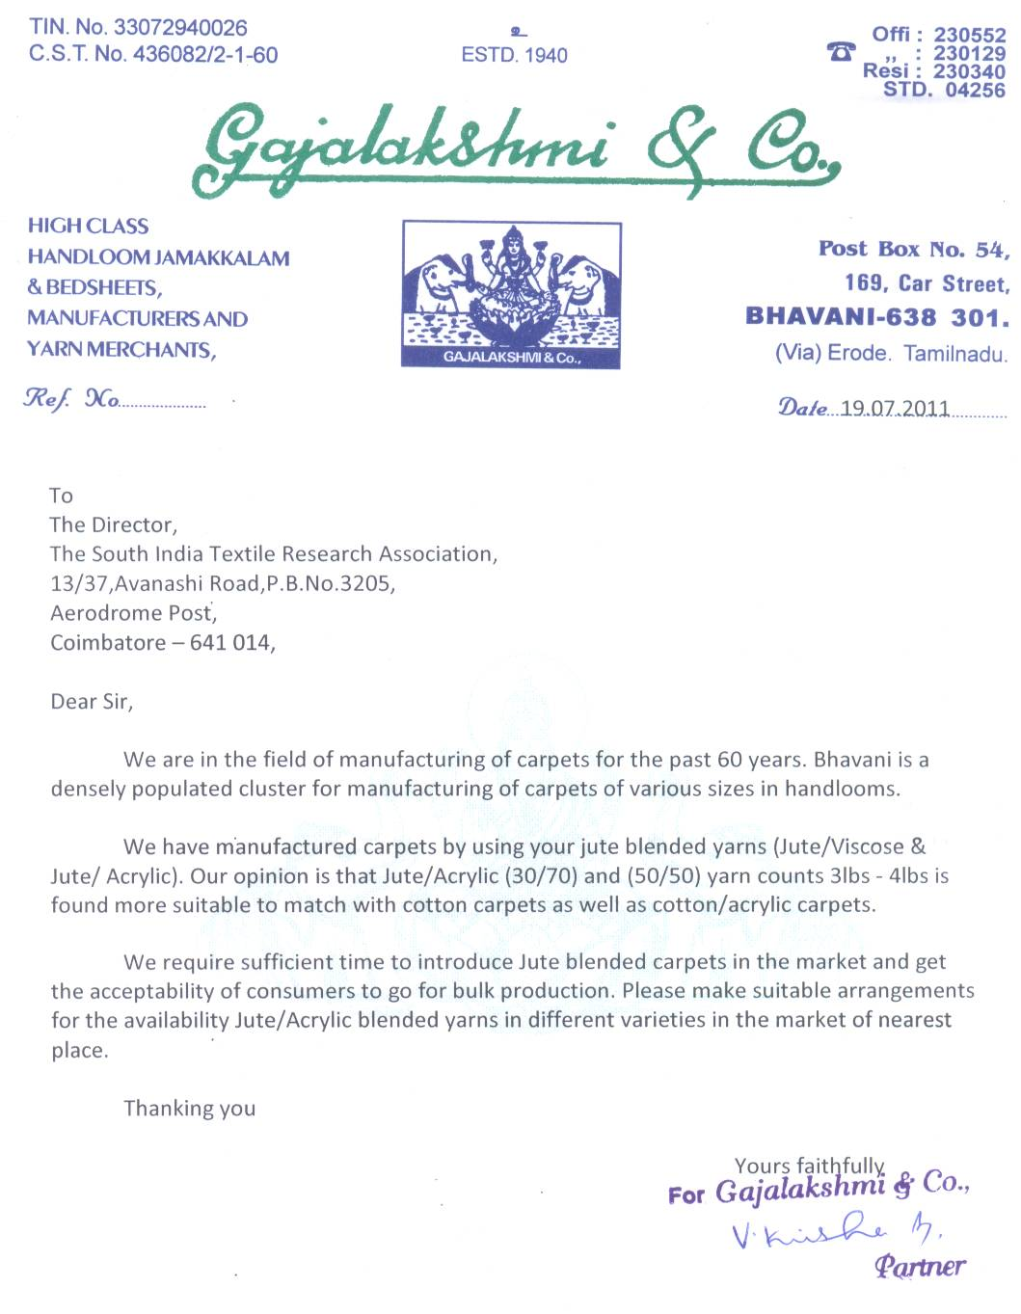

Market Potential for Carpets – Using Jute Blended Yarns (Contd..)

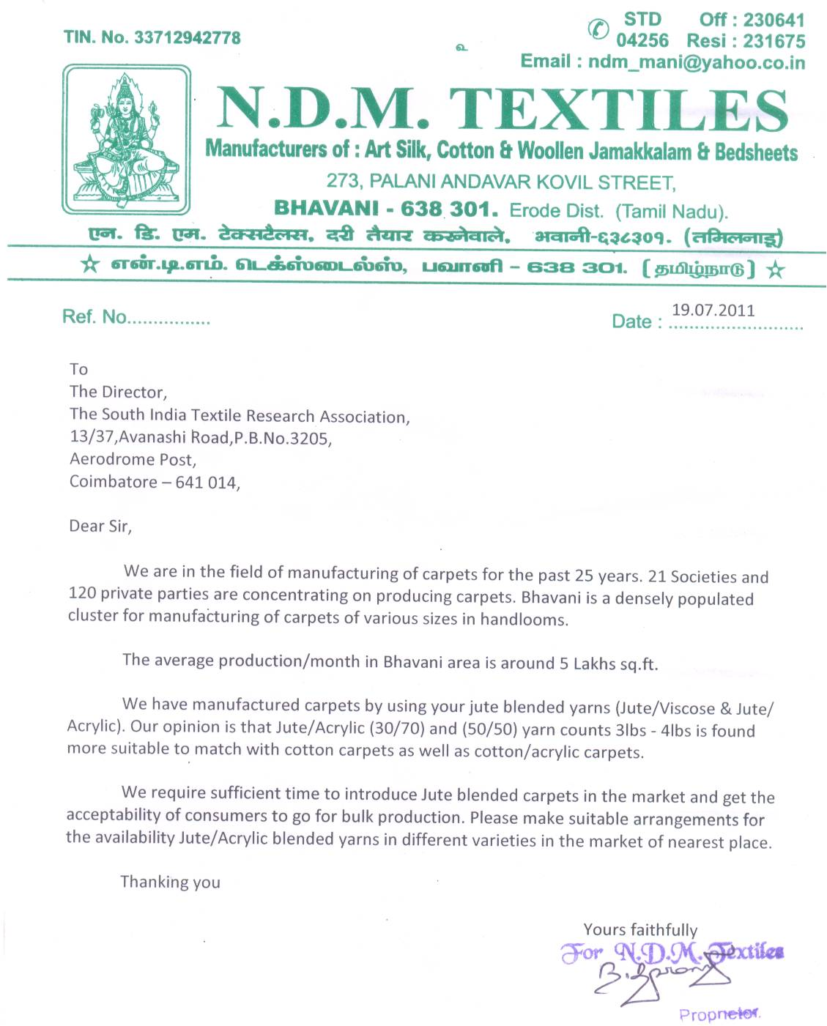

Appendix – III

Market Potential for Tapes and Braided Cords – using Jute Blended Yarns

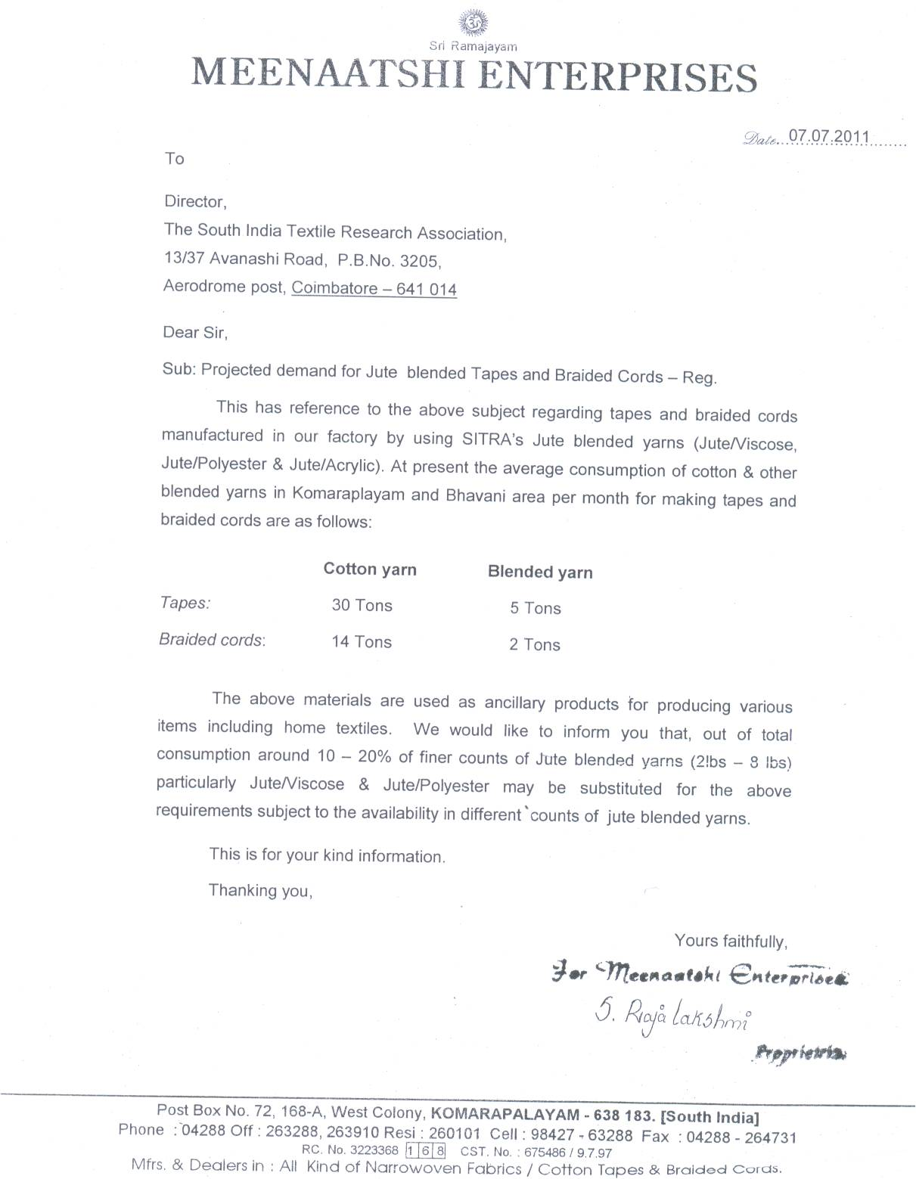

Appendix – IV

Investment required to establish a small unit for making Braided Cords and Tapes

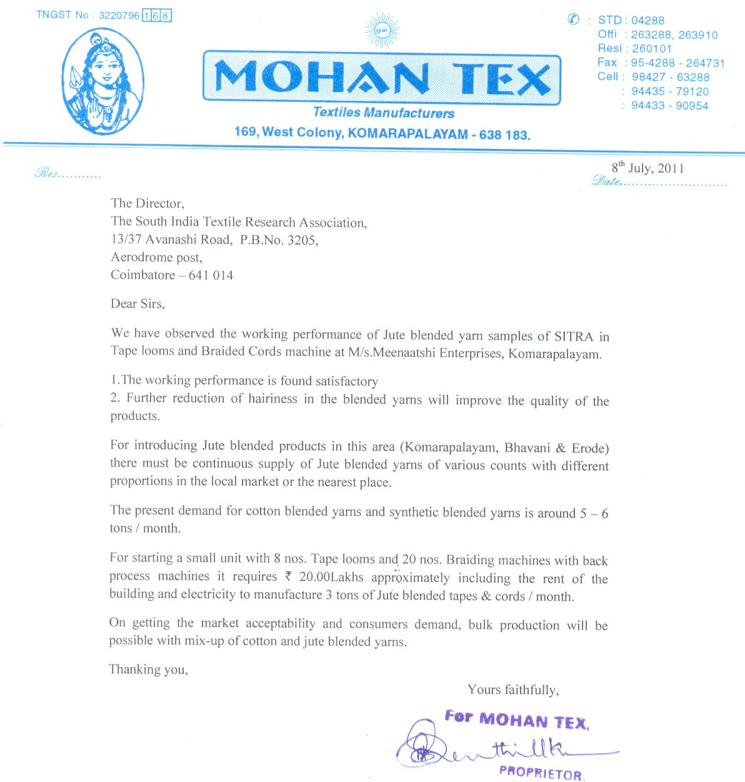

Appendix – V
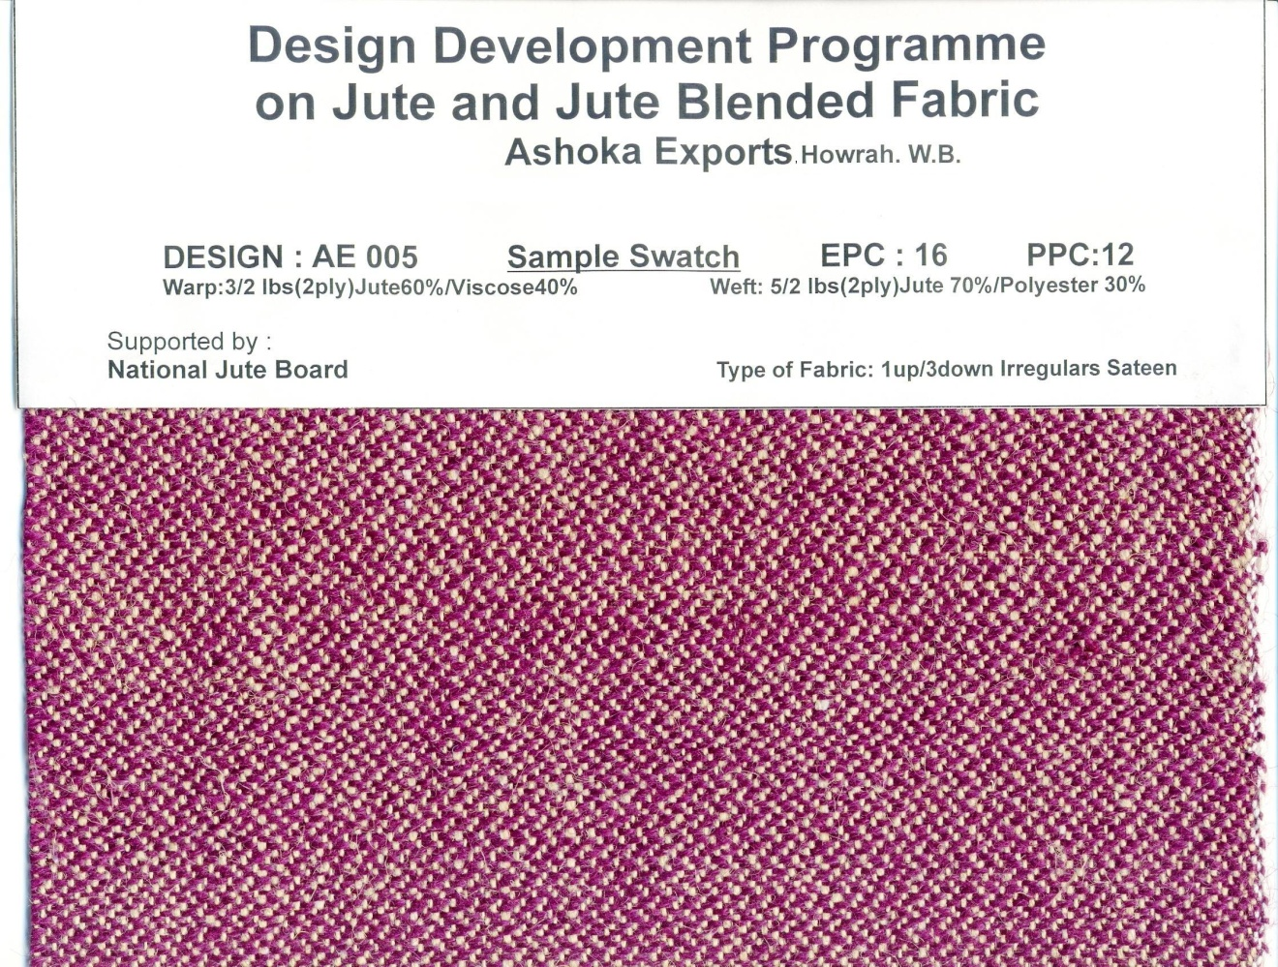

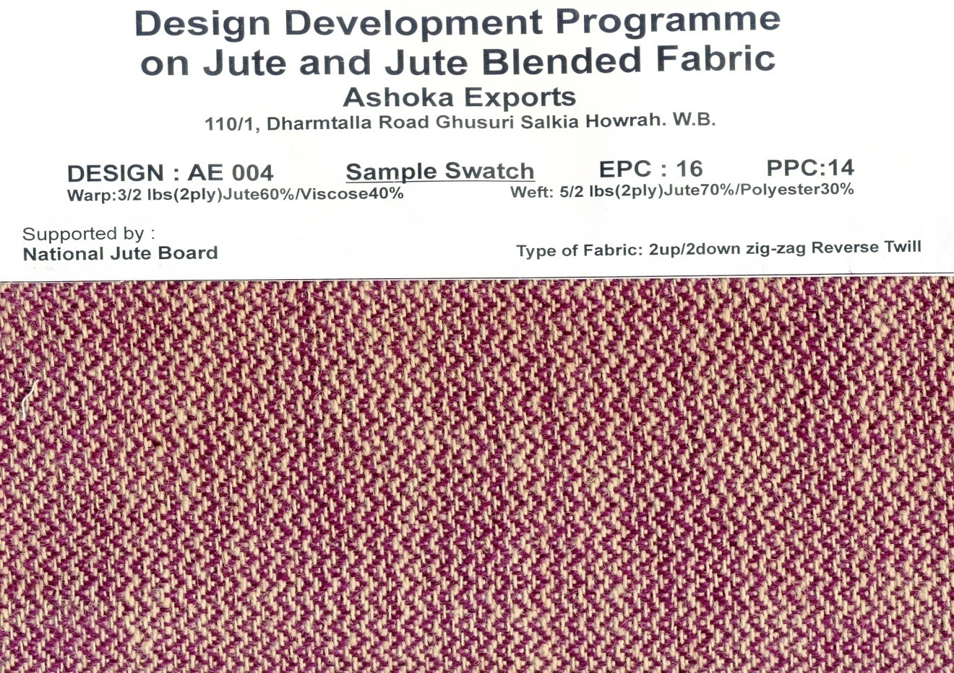

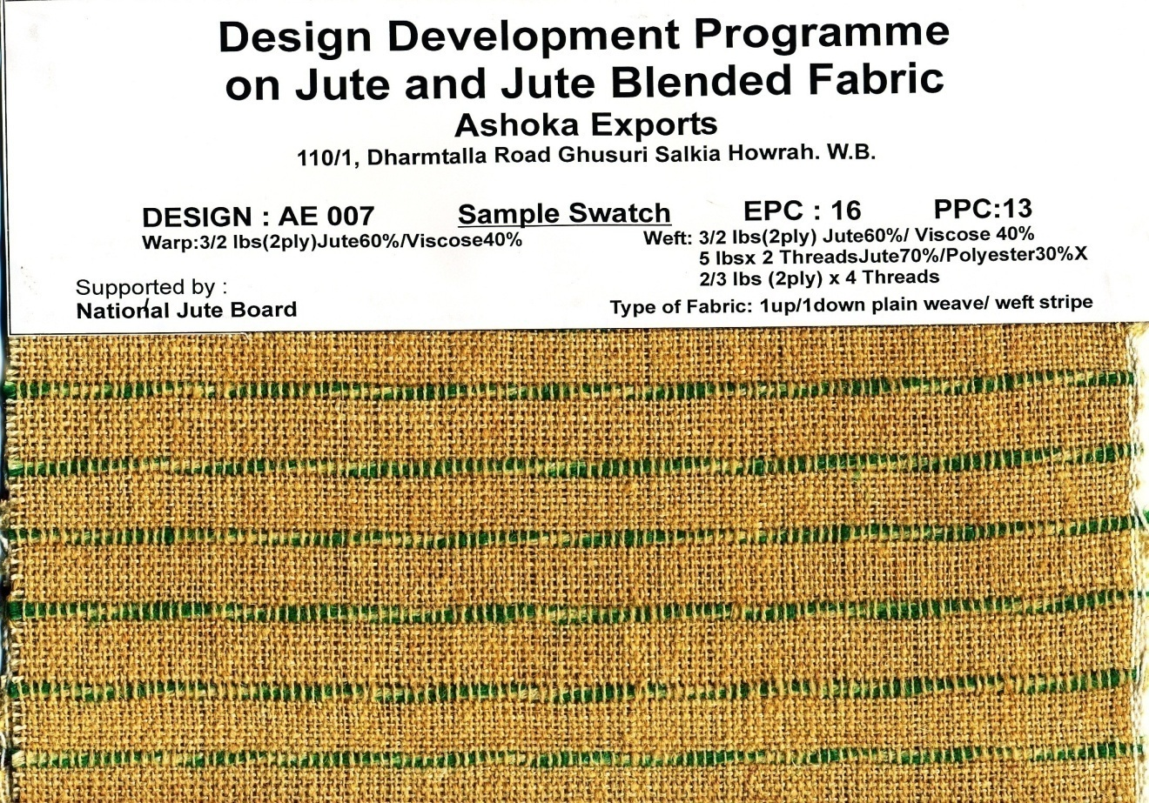

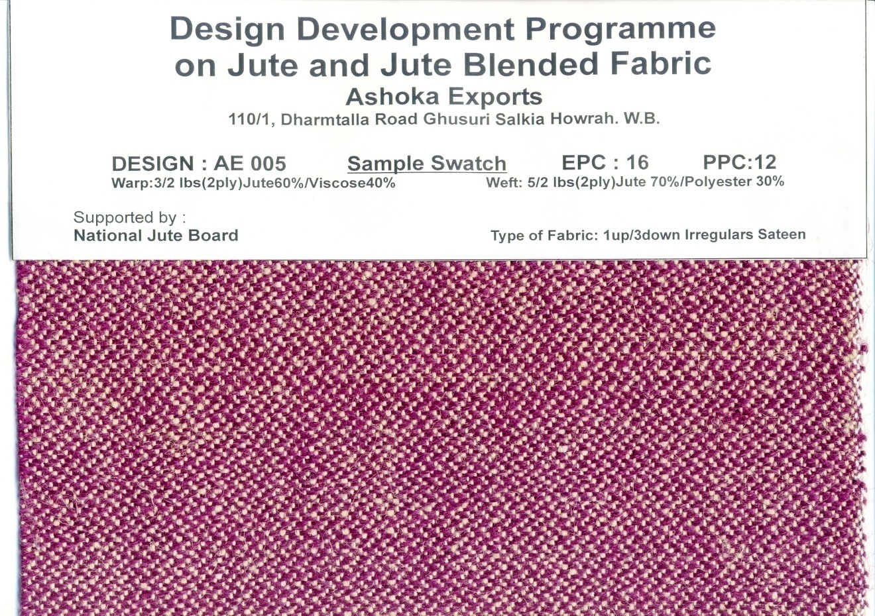

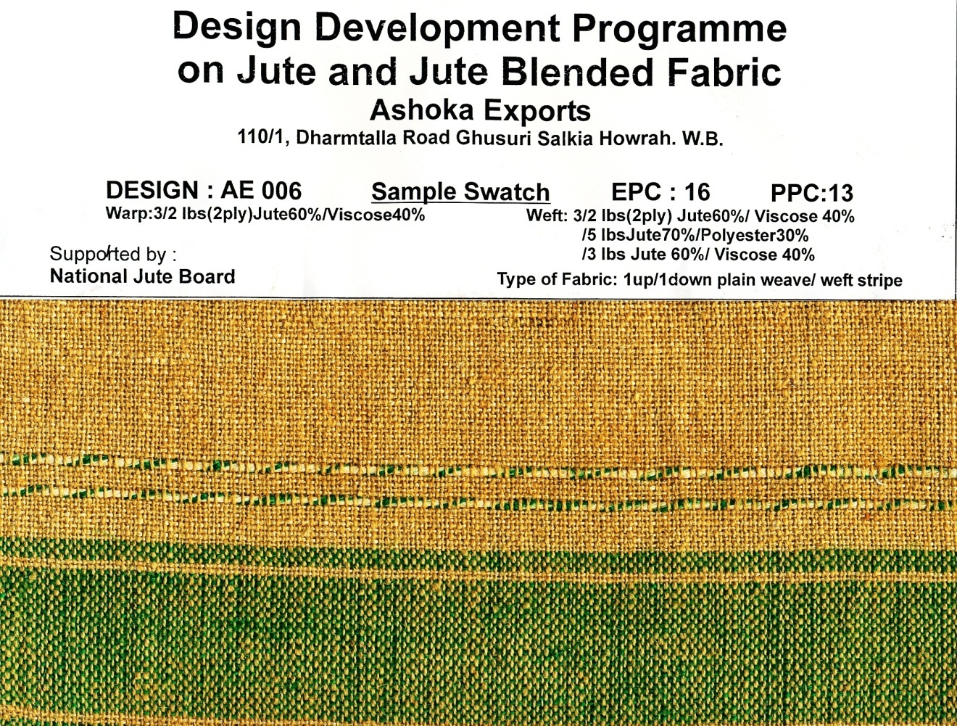

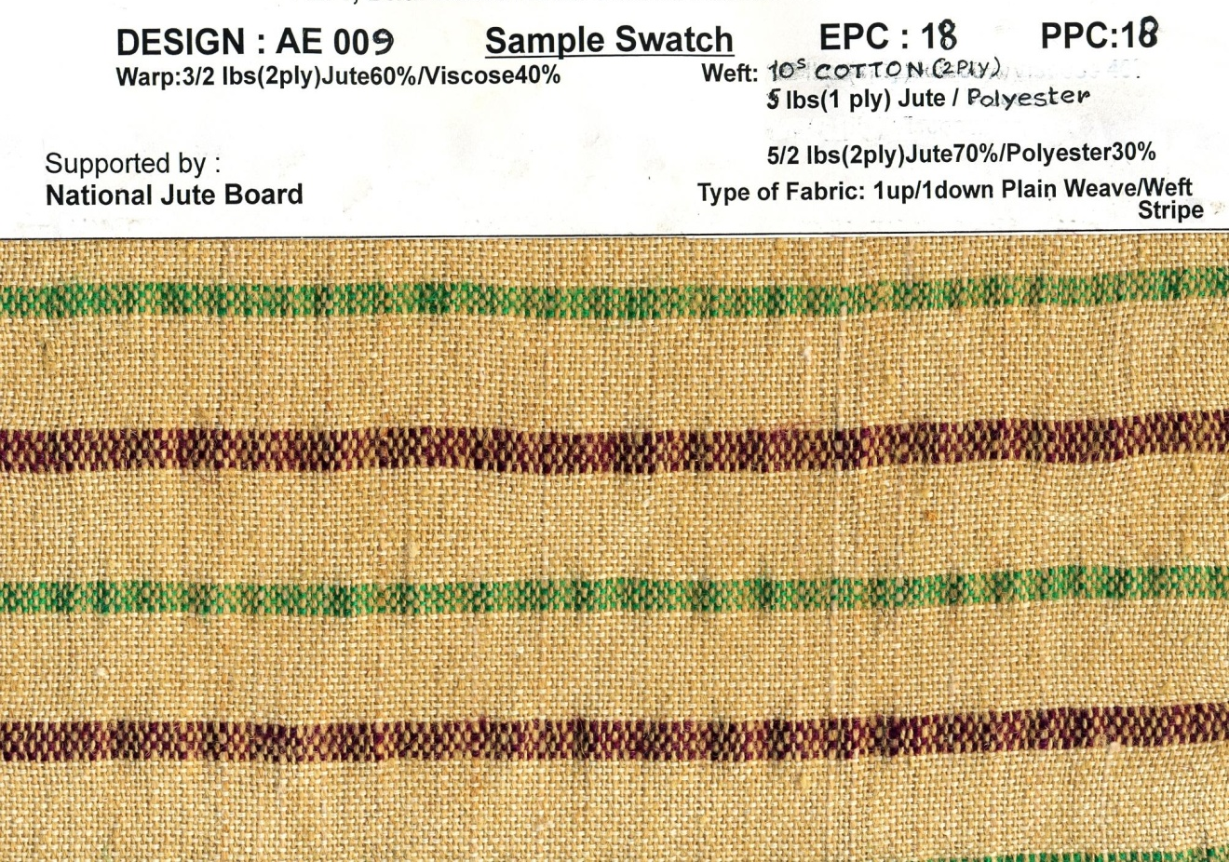

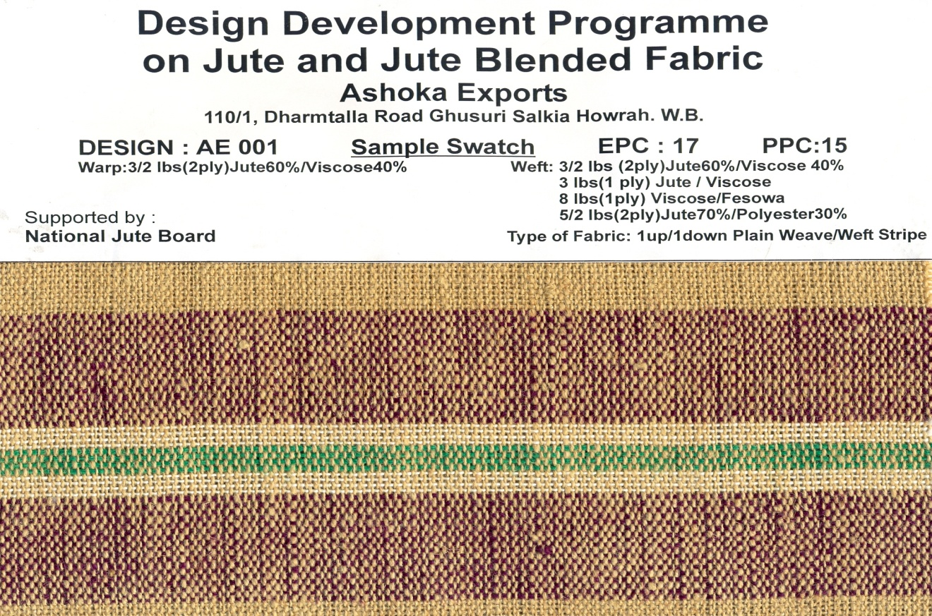

Appendix – VI

Deliverables at the End of the Project

(i) Jute Blended Yarns

(a) Jute/Viscose blended yarns
(single as well as doubled) : 100 kg.

(b) Jute/Acrylic blended yarns
(single as well as doubled) : 100 kg.

(c) Jute/Polyester blended yarns
(single as well as doubled) : 100 kg.

(ii) Fabrics made from Blended Yarns

(a) Jute/Viscose
Fabrics - 60 m
Tapes - 30 m
Cords - 60 m

(b) Jute/Acrylic

Fabrics - 60 m
Tapes - 30 m
Cords - 40 m

(c) Jute/Polyester

Fabrics - 30 m
Tapes - 50 m
Cords - 50 m

Appendix – VII

Details on Different Types of Braiding Technology

CONSTRUCTION OF BRAIDED STRUCTURES
The geometry of the braided structure is directly related to the machinery that forms the fabric. Braiding is classified as (i) two and (ii) three-dimensional braiding. Two-dimensional braided structures can be circular or flat. Three-dimensional braiding is relatively new and was developed mainly for textile structural composites.
DIFFERENT TYPES OF BRAIDED STRUCTURES
Two dimensional braiding
A two-dimensional circular or flat braid is formed by crossing a number of yarns diagonally, so that each yarn passes alternatively over and under one or more of the others. The common designs for two-dimensional braids are as follows:
⎯ Diamond braid of 1/1 intersection repeat
⎯ Regular braid of 2/2 intersection repeat

⎯ Hercules braid of 3/3 intersection repeat

The above designs or patterns are shown in figure 1.
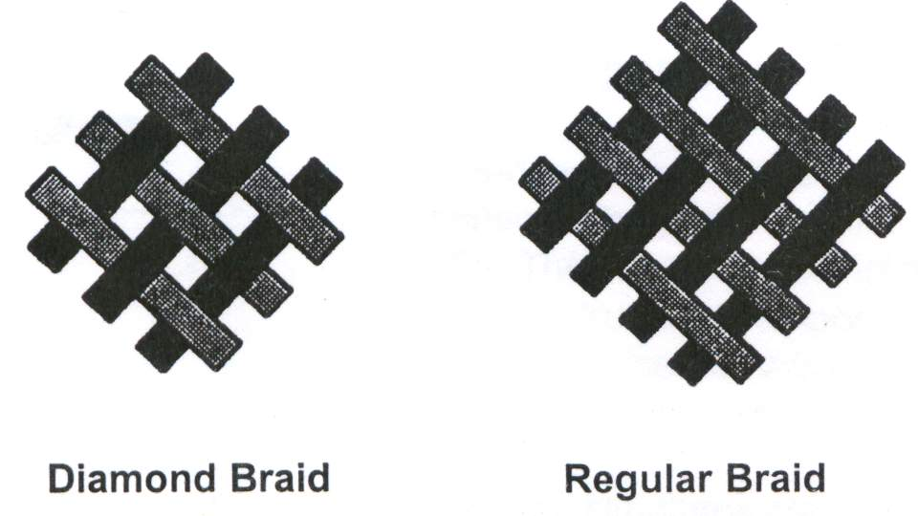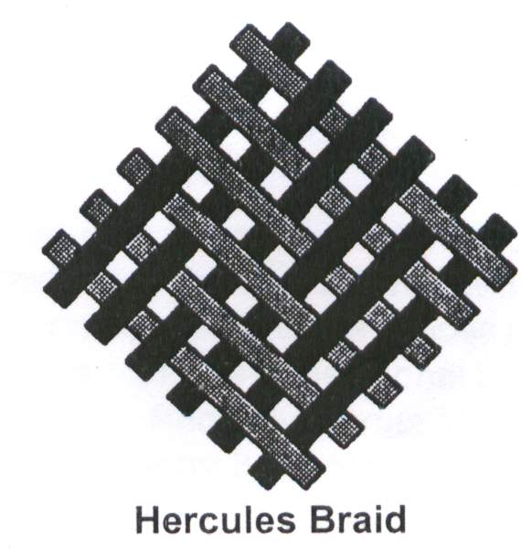
Figure 1 Common Types of Braiding Patterns

The schematic diagram of braided fabric structure along with fabric parameters are shown in Figure 2.

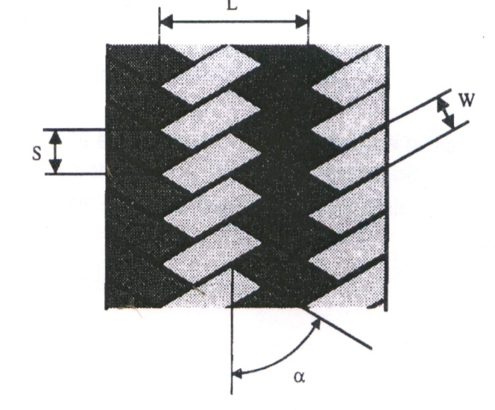
Figure 2 Schematic diagram of Braided Fabric Structure

Braided fabrics are specified by the two threads ie., line and stitch. In Fig.1, the width 'L' is called line and the length’s’ is called stitch or pick. W is the width of yarn from which the braid is made. Braided structures are specified by the line and stitch numbers. 'α' is the braid angle which specifies the angle by which the yarns lay from the direction of machine axis. Braid angle is determined from the relation between the take-up speed and carrier speed.
For composite manufacturing triaxial braiding structures (Figure 3) is used. Here the axial yarns do not interlace or intertwine with other yarns and are trapped between the two sets of yarns in the structure.
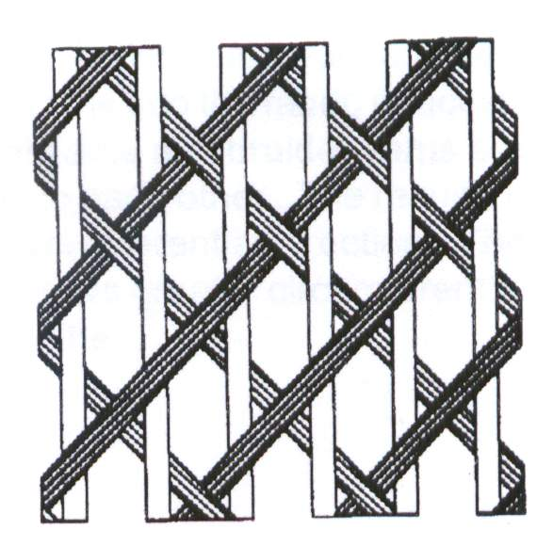
Figure 3 Triaxial Braid

Circular Braiding
Circular (tubular or round) braids are formed hollow or around a center core. A circular braiding machine consists of two sets of an even number of spools containing the braiding yarns. One set runs clockwise around the center of the machine and the other set turn in counter clockwise direction (Figure 4).
Yarn Spools
Fabric
Mandrel
Figure 4 Circular Braiding Machine

While revolving in opposite directions, the carriers are diverted to pass alternatively inside and outside (under & over) one another. The clockwise and anticlockwise paths cause the two sets of yarns to intersect, this producing a tubular braid. The yarns from the bobbins are collected above the hub of the circular track in which the bobbins travel. Since the speed of the yarn carriers is constant, the openness of the fabric is changed by changing the take-up speed of the fabric. Circular braids are also called “may pole” braids since their motion is similar to the “may pole” dance.
The tube can be braided about a central core of yarns, thus producing a solid braid composed of a core and "sleeve". The core in fact can be any shape and material. This is the reason why circular braiding is widely used in composite preform manufacturing ; unlike weaving or knitting, the braiding structure conforms to the core very well thus making it easy to develop braided structures of complex shapes. Depending upon the number of spools (carriers), the nature of the yarn, the path of the spools and the core, endless numbers of braided structures can be produced.
Flat Braiding
Flat braids are made in the form of tape or flat strip. In flat braiding, instead of following two continuous paths, the carriers turn around or reverse direction at two given points called "terminals" and then continue on the opposite track. (Figure 5) i.e. the track does not complete a circle.

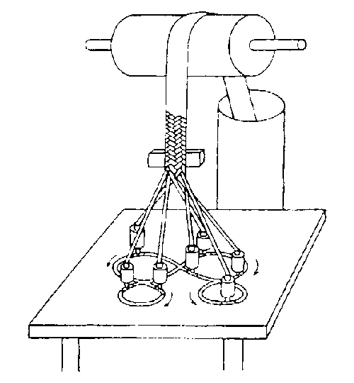
e
a
b
f
d
c
a : track plate, b : spool carrier, c: braiding yarn, d: braiding point
and former, e: take off roll with change gears, f : delivery can
Figure 5 Flat Braiding
The size of the braid is governed by the following factors:
- The number of carriers: Tubular braiders have an even number of carriers and flat braiders usually have an odd number of carriers. The minimum number of carriers is three, which gives a basic diamond braid similar to a girl's plaited hair.
- The diameter of the yarns.
- The number of yarn ends per carrier.
- The number of yarns per unit length.
Three Dimensional Braiding
Three-dimensional braiding is relatively new concept compared to two-dimensional braiding. The three dimensional braiding concept has been developed mainly for textile structural composites. Every different three dimensional braided structure requires a different machine with specific characteristics and dimensions. Therefore, companies and research institutions custom-build their 3 D braiding machines. Two examples of 3 D braiding processes are (i) four step process and (ii) two step process.
The four step process is shown in Figure 6.
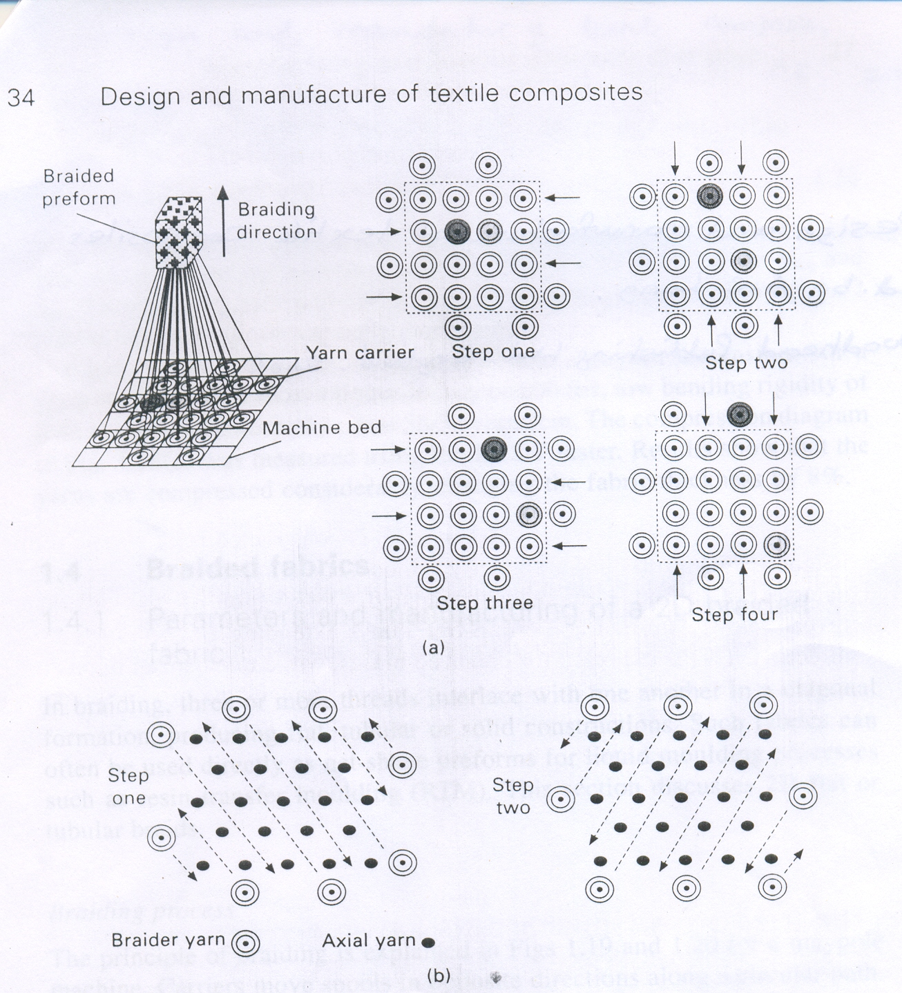
Figure 6 Schematic illustration of four step braiding processes

This process uses a framework of yarn carriers in a rectangular or circular array. As the name suggests, the process consists of four steps, each involving alternate movements of the rows and columns of yarn carriers. Between cycles the yarns are ‘beaten up’ into the structure and the braid is hauled off by one pitch length. In the 4 step braiding method, the yarns are intertwined to form a multi-layer 3 D structure as shown in figure 7.
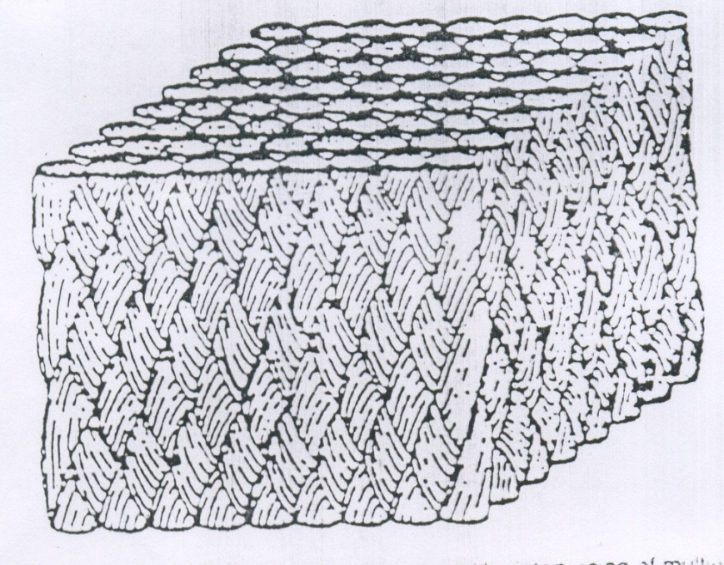
Figure 7 Three dimensional braid produced by
Inter-twining of multi yarns
The two step process is shown in figure 8. This process involves a large number of axial yarns arranged in the required preform geometry, with a smaller number of yarn carriers arranged around them. The carriers are moved through the array of axial yarns in two alternate directions.

Figure 8 Schematic illustration of two step braiding processes
Such processes can be used to produce preforms featuring yarns that extend along many directions. Yarn directions are not limited to a plane, and this constitutes the main advantage of the process. However, any increase in out-of-plane properties is achieved at the expense of in-plane properties. 3 D braids generally feature axial yarns. Preforms of various shapes can be produced, for composite parts of which the geometry is very different to the shells associated to parts based on 2 D textiles such as weaves or non-crimp fabrics. Such applications are still relatively rare; rocket engines constitute a classic example while biomedical engineering is one area of emergence.
3 D braiding method is very versatile to produce various near net shapes and structures. It is even possible to produce nuts and bolts with a braiding system. Some of the net shape structures that can be produced by 3 D braiding are shown in figure 9.

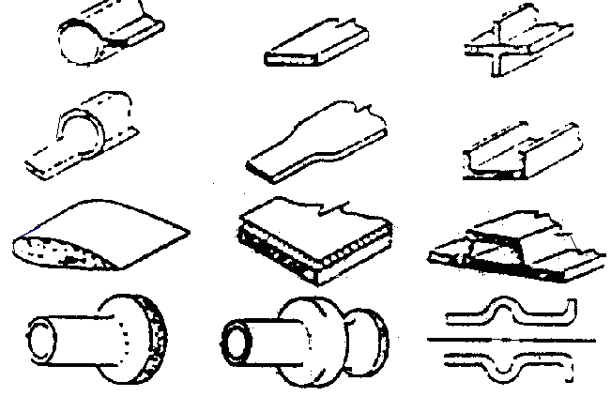
Figure 9 Various net shape structures that can be
Produced by 3 D braiding

PROTECTIVE TEXTILES THAT CAN BE MANUFACTURED USING BRAIDING TECHNOLOGY
Para-aramid filaments are used in fibre optic cables, air and sea towed antennae and acoustic arrays. The principal function of the reinforcement in fibre-optic and electromechanical cables is to limit the strain on the optical and electrical conductors and thereby avoiding material failure. In this process, zero twist filament yarns are laid around the inner part of the polycarbonate moulded opto-electric cable.

The main disadvantage of this process is that as the para-aramid filaments are use without any integrated structure, the filaments, are getting displaced during usage. Due to displacement of para-aramid filaments, in the reinforced structure, heavy strain is imparted on inner optical and electrical conductors and hence frequent material failure occurs which affect the communication process.

In order to avoid this, braided structures made out of para-aramid filament yarns could be used (figure 10).

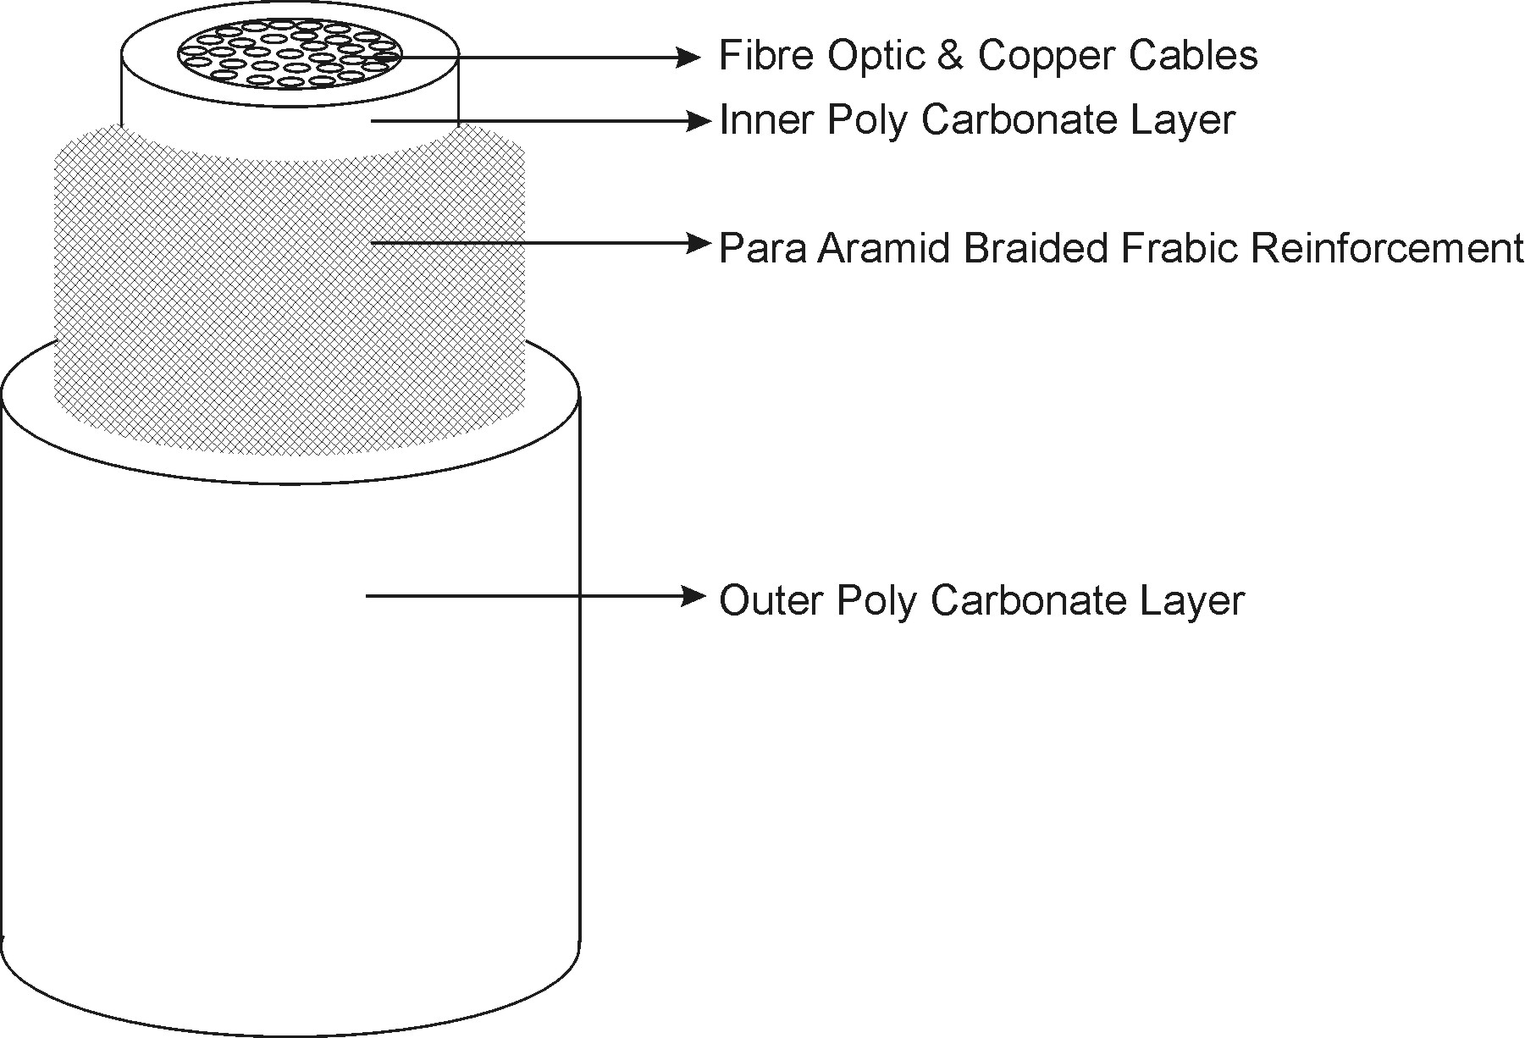
Figure 10. Opto-electronic cables reinforced by
para-aramid braided fabric

Original Project Sanction Letter from NJB, Kolkata
Original Project Sanction Letter from NJB, Kolkata (Contd..)

